BILLNOVA: THE SMART BILLING SYSTEM
A Project Report
Submitted in partial fulfillment of the
Requirement for the award of the Degree of
BACHELOR OF SCIENCE (COMPUTER SCIENCE)
By
MISHRA SHARANYA SHESHNATH
Seat number: 510513823
Under the esteemed guidance of
Mrs. PRAJAKTA BHOIR
Designation

Assistant Prof.

DEPARTMENT OF COMPUTER SCIENCE
ABHINAV DEGREE COLLEGE
(Affiliated to University of Mumbai)
Mumbai - 401105, Maharashtra
2026-2027

ABHINAV DEGREE COLLEGE
(Affiliated to University of Mumbai)
BHYNADER , Maharashtra - 401105
DEPARTMENT OF COMPUTER SCIENCE

CERTIFICATE
This is to certify that the project entitled, "BILLNOVA: SMART BILLING SYSTEM”, is bonafide work MISHRA SHARANYA SHESHNATH bearing Seat.No. 510513823 submitted in partial fulfillment of the requirements for the award of degree of BACHELOR OF SCIENCE in COMPUTER SCIENCE from University of Mumbai.

-------------------------------------- -------------------------------
INTERNAL GUIDE COORDINATOR

--------------------------------
EXTERNAL EXAMINER

DATE: COLLEGE SEAL

DECLARATION

I hereby declare that the project entitled “BillNova – Smart Billing Management System” has been carried out and submitted by me, MISHRA SHARANYA SHESHNATH, in partial fulfillment of the requirements for the degree of Bachelor of Science in Computer Science (B.Sc. Computer Science) at Abhinav College of Arts, Commerce & Science, affiliated with the University of Mumbai, under the guidance of Mrs. Prajakta Bhoir, during the academic year 2026–2027.
This project is an original piece of work carried out by me and has not been submitted to any other university or institution for the award of any degree, diploma, or certification. All information, data, and results presented in this project are true to the best of my knowledge. Wherever external sources have been used, due acknowledgment has been given.

----------------------------
Sharanya Mishra

ACKNOWLEDGEMENT
I would like to express my sincere gratitude to everyone who supported and guided me throughout the development of my project entitled “BillNova – Smart Billing Management System.”
First and foremost, I am grateful to the Principal, MR. Alwin Menzes , HOD of IT/CS department: MR. Vicky Patil and the management of Abhinav College of Arts, Commerce & Science for providing me with the opportunity and necessary support to undertake this project as part of my Bachelor of Science in Computer Science (B.Sc. Computer Science) curriculum.
I would like to express my sincere thanks to my project guide, Mrs. Prajakta Bhoir, for her valuable guidance, encouragement, and suggestions throughout the development of this project. Her support helped me understand the project requirements and improve my approach towards designing and developing the system.
I am also thankful to all the faculty members of the Computer Science Department for their academic guidance and for providing me with the knowledge and skills required to complete this project. Their teaching and support have contributed to my learning and understanding of software development.
I would also like to thank my family and friends for their encouragement, patience, and support throughout the project work. Their motivation helped me remain focused and complete the work to the best of my ability.
Finally, I would like to acknowledge all the books, documentation, and other learning resources that helped me understand the technologies used in this project, including Python, Flask, MySQL, HTML, and CSS.
This project has been a valuable learning experience, allowing me to apply my theoretical knowledge to practical software development and improve my technical and problem-solving skills.
MISHRA SHARANYA SHESHNATH
B.Sc. Computer Science
Academic Year: 2026–2027

ABSTRACT
Project Title: BillNova – Smart Billing Management System
BillNova – Smart Billing Management System is a software application developed to simplify and organize the billing process for businesses. The main objective of this project is to reduce manual work, improve billing accuracy, and maintain business records efficiently. Traditional billing methods often require considerable time and effort for managing products, customer information, invoices, and calculations. BillNova aims to provide a systematic and user-friendly solution to these challenges.
The system is developed using Python, Flask, MySQL, HTML, and CSS. Python and Flask are used to implement the application logic, while MySQL is used to store and manage information in a structured database. HTML and CSS are used to design the user interface. The system is intended to support essential billing operations, including product management, customer management, invoice generation, and the maintenance of relevant records.
BillNova helps organize product and customer information and simplifies invoice preparation by calculating applicable amounts and taxes according to the system's configuration. It also provides a centralized approach to storing billing-related data, making records easier to access and manage. The system is designed with the aim of improving efficiency, minimizing calculation errors, and providing a consistent billing workflow.
The project follows an incremental development approach, allowing the system to be developed and improved module by module. Testing is important to verify the correctness of individual functions, database operations, input validation, and the overall billing workflow.
In conclusion, BillNova aims to provide a practical and organized billing solution for businesses by combining billing operations, database management, and a simple user interface in one application. It can be enhanced in the future with additional reporting features, improved security, backup facilities, and other business-management capabilities.

TABLE OF CONTENTS
Sr. No. | Sub No. | Topic | Page No.
 |  | PRELIMINARY PAGES
 |  | Title Page | 1
 |  | Certificate | 2
 |  | Declaration | 3
 |  | Acknowledgement | 4
 |  | Abstract | 5
 |  | Table of Contents | 6
 |  | Approved Copy of Project Proposal | 7
 |  | Plagiarism Scan Report | 8
CHAPTER 1 |  | INTRODUCTION | 10
 | 1.1 | Background | 12
 | 1.2 | Objectives | 14
 | 1.3 | Purpose and Scope | 16
 | 1.3.1 | Purpose | 17
 | 1.3.2 | Scope | 18
 | 1.3.3 | Applicability | 19
 | 1.4 | Overview of BillNova | 20
CHAPTER 2 |  | SURVEY OF EXISTING SYSTEM | 21
 | 2.1 | Existing System | 22
 | 2.2 | Limitations of Existing System | 23
 | 2.3 | Proposed System | 24
 | 2.4 | Methodology | 25
CHAPTER 3 |  | REQUIREMENT AND ANALYSIS | 26
 | 3.1 | Problem Definition | 27
 | 3.1.1 | Current System | 28
 | 3.1.2 | Proposed System | 28
 | 3.1.3 | Feasibility Study | 29
 | 3.2 | Requirement Specification | 29
 | 3.2.1 | Functional Requirements | 30
 | 3.2.2 | Non-Functional Requirements | 31
 | 3.3 | Planning and Scheduling | 32
 | 3.3.1 | Gantt Chart | 33
 | 3.3.2 | PERT Chart | 34
 | 3.3.3 | Activity Chart | 34
 | 3.4 | Software and Hardware Requirements | 35
 | 3.5 | Preliminary Product Description | 37
 | 3.6 | Conceptual Model | 40
 | 3.7 | Cost-Benefit Analysis (COCOMO Model) | 42
CHAPTER 4 |  | SYSTEM DESIGN | 44
 | 4.1 | Use Case Diagram | 45
 | 4.2 | Activity Diagram | 46
 | 4.3 | Class Diagram | 47
 | 4.4 | ER Diagram | 48
 | 4.5 | Component Diagram | 49
 | 4.6 | Deployment Diagram | 50
 | 4.7 | Data Flow Diagram (DFD) | 51
 | 4.8 | Website/Application Workflow Diagram | 52
 | 4.9 | System Behaviour Diagram | 53
 | 4.10 | List of Database Tables | 54
CHAPTER 5 |  | IMPLEMENTATION AND TESTING | 55
 | 5.1 | Tools and Technologies Used | 56
 | 5.2 | Application Screenshots | 59
 | 5.3 | Coding Details and Implementation | 63
 | 5.3.1 | Backend Implementation | 65
 | 5.3.2 | Frontend Implementation | 67
 | 5.3.3 | Database Connectivity and Management | 69
 | 5.3.4 | Code Efficiency | 73
 | 5.4 | GitHub Repository | 75
 | 5.5 | Testing Approaches | 76
 | 5.5.1 | Unit Testing | 78
 | 5.5.2 | Integration Testing | 80
 | 5.5.3 | Beta Testing | 82
 | 5.6 | Types of Testing | 83
 | 5.7 | Test Cases | 85
 | 5.8 | Test Reports | 87
CHAPTER 6 |  | MAINTENANCE | 89
 | 6.1 | Conclusion / Project Summary | 90
 | 6.2 | Limitations | 91
 | 6.3 | Future Enhancements | 92
CHAPTER 7 |  | REFERENCES | 93
CHAPTER 8 |  | GLOSSARY | 95
CHAPTER 9 |  | APPENDIX | 97
 | 9.1 | Sample Database Structure | 98
 | 9.2 | Sample Input and Output | 99
 | 9.3 | Sample Test Case Record | 100
 | 9.4 | Project Screenshots | 101
 | 9.5 | Source Code and Repository Details | 101
 | 9.6 | Supporting Documents | 102

Synopsis
Project Title: BillNova – Smart Billing System

Introduction
BillNova is a desktop-based billing and inventory management system developed to simplify the billing process for small and medium-sized businesses. The system enables users to manage products, customers, invoices, and sales records through an easy-to-use interface. It reduces manual work, improves billing accuracy, and maintains digital records for future reference.

Objective & Scope of project
The main objective of this project is to develop an efficient billing application that automates invoice generation, maintains product inventory, stores customer information, and generates sales reports. The system aims to save time, minimize human errors, and improve business operations.
The project is suitable for:
- Grocery Stores
- Medical Shops
- Clothing Stores
- Electronic Shops
- Stationery Shops
- General Retail Businesses
The system can be further expanded to support multiple branches and online billing.

Technologies Used
- Frontend: HTML, CSS, Bootstrap, JavaScript
- Programming language: Python flask
- Backend:
- Database: MY SQL,
- Database management tool: MY SQL Workbench
- IDE: Visual Studio Code (VS Code)

Modules
- User Login and Authentication
- Customer Management
- Product Management
- Billing and Invoice Generation
- Inventory Management
- Sales History
- Report Generation

Features
- Secure login for authorized users.
- Add, update, delete, and search products.
- Maintain customer details.
- Automatic bill calculation with GST support.
- Generate and print invoices.
- Update stock automatically after each sale.
- Store sales records in the database.
- Search and view previous bills.

Expected Outcome
The system will provide a fast, reliable, and user-friendly billing solution that helps businesses manage sales and inventory efficiently. It will reduce paperwork, improve record management, and generate professional invoices.

SDLC Model Used – Incremental Model

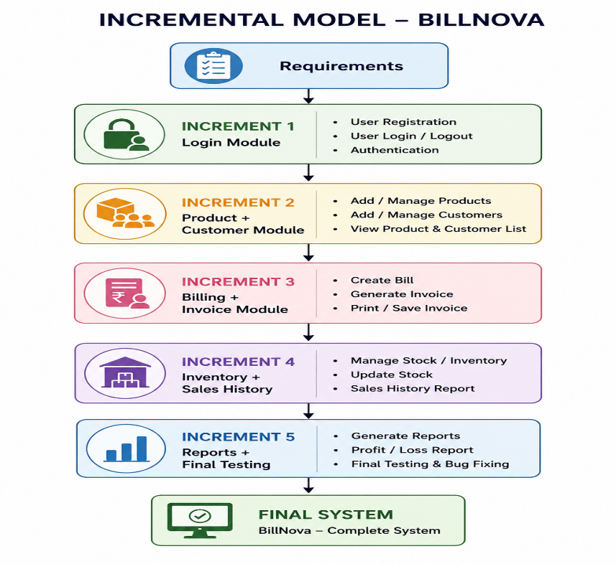
- The project follows the Incremental SDLC Model.
- The system is developed module by module instead of all at once.
- Each module is designed, implemented, and tested before moving to the next module.
- It helps in detecting and fixing errors at an early stage.
- New features can be added without affecting existing modules.
- This model is suitable for BillNova because it consists of independent modules such as Login, Product Management, Customer Management, Billing, Inventory, and Reports.
Advantages
- Fast and accurate bill generation.
- Reduces manual calculations and paperwork.
- Maintains customer and product records digitally.
- Automatically updates inventory after every sale.
- Generates professional invoices.
- Stores sales history for future reference.
- Easy to use with a simple and user-friendly interface.
- Saves time and improves overall business efficiency.
- Reduces the chances of human error.
- Can be upgraded with additional features in the future.
Limitations / Disadvantages
- Designed primarily for small and medium-sized businesses.
- Requires a computer system to operate.
- Data may be lost if regular database backups are not maintained.
- Internet-based features such as cloud storage and online synchronization are not available in the current version.
- Barcode scanning is not supported in the current implementation.
- Multi-user access with different permission levels is not available.
- Online payment gateway integration is not included.
- The system depends on proper maintenance of the MySQL database.

Future Scope
- Barcode scanner integration.
- QR code-based digital payments.
- Cloud database synchronization.
- Mobile application support.
- Analytics dashboard for business insights.
- Email and WhatsApp invoice sharing.
- Multi-user and role-based access control.

Conclusion
BillNova is designed to provide a complete billing and inventory solution for retail stores and small businesses. By automating billing and maintaining digital records, the system improves efficiency, accuracy, and customer service while reducing manual effort.

PLAGARISM REPORT

BILLNOVA – SOURCE CODE SIMILARITY
Illustrative chart layout
70
% / 30%
70
% Human-written
30
% Similarity
Project details
Project | BillNova – Smart Billing System
Technology | Python, Flask, HTML/CSS/JavaScript, MySQL
Chart values | 70% human-written / 30% similarity
Verification status | verified by a source-code scan
Important interpretation
The uploaded scan report states 30% matched and 70% unique for a 51-word sample, with zero public-web sources examined. This does not establish a verified similarity score for the complete BillNova project. The 70/30 donut is an illustrative visualization of requested values only and can be represented as an actual scan result.

CHAPTER 1:INTRODUCTION

Introduction
In the modern business environment, billing is an essential activity for organizations that sell products or provide services. Every business needs to maintain proper records of its products, customers, invoices, quantities, prices, and transactions. Managing these activities manually can become time-consuming, particularly when the number of customers and transactions increases. Manual billing may also lead to calculation errors, repeated data entry, difficulties in retrieving previous invoices, and problems in maintaining organized records.
To overcome these challenges, computerized billing management systems are used to simplify billing operations and improve the organization of business information. These systems help businesses maintain records systematically, perform calculations, prepare invoices, and retrieve information when required. They also reduce dependence on handwritten bills, paper registers, and separate records.
BillNova — Smart Billing Management System is a software project designed to simplify billing activities and provide an organized method of managing essential business information. The system aims to bring billing-related operations together through a common application. It focuses on activities such as product management, customer management, invoice preparation, and maintaining relevant business records in a structured database.
The primary purpose of BillNova is to make routine billing activities easier, faster, and more systematic. Instead of repeatedly entering the same product and customer information, users can maintain records in the application and use the available information while performing billing operations. This approach can reduce repetitive work and improve the consistency of business records.
The project uses Python as the programming language, Flask as the web framework, MySQL as the database management system, and HTML, CSS, and JavaScript for developing the user interface. These technologies work together to provide an application in which user actions, application logic, and stored information are connected.
Python is used to implement the application's processing logic and billing-related operations. Flask provides the framework for handling application routes and requests. MySQL stores structured information, while HTML and CSS define the structure and appearance of the interface. JavaScript can be used to support interactive elements where required. The database connection allows the application to perform supported operations on stored records.
BillNova is intended to provide a user-friendly environment in which users can access the available billing functions without dealing with the complexity of managing separate registers or performing every calculation manually. The system aims to maintain product information, customer details, and invoice records in an organized manner.
Another important aspect of the project is the systematic handling of billing calculations. Invoices may contain product quantities, unit prices, subtotals, and applicable taxes. The application is intended to perform the calculations supported by its implementation and display the resulting amounts in a structured invoice. Where applicable, GST components such as Central Goods and Services Tax (CGST) and State Goods and Services Tax (SGST) can be included according to the relevant tax configuration and transaction requirements.
The system also provides a foundation for maintaining inventory-related information and accessing previously stored business records, depending on the functions implemented in the final application. These capabilities can help businesses organize their daily operations and make relevant information easier to retrieve.
BillNova is primarily designed around the billing requirements of small businesses, shops, and organizations that need a convenient method of managing products, customers, and invoices. Its basic approach can also be extended to accommodate additional business requirements in the future.
The project is not limited to developing an interface alone. It also involves understanding business requirements, designing a suitable database structure, implementing application logic, connecting the application to the database, validating inputs, and testing the expected behaviour of the system. These activities demonstrate the practical application of programming, database management, and software engineering concepts.
Overall, BillNova aims to provide a structured and convenient billing management solution that reduces repetitive manual effort, supports consistent calculations, and improves the organization of business information. The exact capabilities of the completed system depend on the features implemented and verified during development and testing.

1.1 Objective
The main objective of the BillNova Smart Billing Management System is to simplify and organize billing operations by providing a computerized application for managing invoices, products, customers, and related business records.
The system aims to reduce the difficulties associated with manual billing and provide a more consistent approach to storing and processing billing information. It is designed to make common billing activities easier to perform while improving the accessibility and organization of stored records.
The specific objectives of the project are described below.
1. To simplify the billing process:The system aims to make invoice preparation more convenient by providing a structured process for entering or selecting customer details, product information, quantities, and prices. It is intended to reduce the effort required to prepare bills manually.
2. To automate billing calculations:BillNova aims to perform supported billing calculations through application logic. Calculations may include item subtotals, applicable taxes, and the final invoice amount. This helps reduce repetitive manual calculations and promotes consistency.
3. To maintain product information:The system aims to provide a structured method of maintaining product details, such as product names, prices, quantities, and applicable tax information. Properly maintained product records can simplify product selection during invoice preparation.
4. To manage customer records:application aims to store and organize customer information required for billing. Depending on the implemented fields, this information may include customer names, contact details, email addresses, billing addresses, and relevant tax details.
5. To maintain invoice records:The system aims to store relevant invoice information in a database so that users can access previously saved records through the available application functions. This can help reduce dependence on paper-based invoice storage.
6. To improve the accuracy of billing information:The project aims to reduce common billing mistakes by using defined calculation rules and structured data entry. The correctness of the results depends on accurate input, proper implementation, and adequate testing.
7. To provide centralized data storage:BillNova uses MySQL as its database management technology to organize relevant business information. Centralized storage can make it easier to maintain relationships between products, customers, invoices, and associated invoice items.
8. To reduce repetitive data entry:By storing product and customer details, the system aims to reduce the need to enter the same information repeatedly. Users can reuse stored information wherever the implemented functions support it.
9. To improve the accessibility of records:The application aims to make it easier to view and retrieve stored product, customer, and invoice information. Organized records can help users access relevant information more conveniently.
10. To provide a user-friendly interface
The project aims to provide a clear and understandable interface for performing billing-related activities. The interface should organize the available functions logically and make routine operations convenient for the intended users.
11. To support inventory-related activities
Where inventory functions are implemented, the system aims to help maintain product quantity information and identify stock-related requirements. This can provide additional support for day-to-day business operations.
12. To improve business efficiency
By organizing billing activities in one application, BillNova aims to reduce unnecessary manual effort and make routine operations more systematic. This may help users devote more time to other business responsibilities.
13. To apply software engineering concepts
The project aims to demonstrate the practical application of requirement analysis, system design, programming, database connectivity, software testing, and maintenance planning in the development of a real-world application.
14. To provide a foundation for future enhancement
The system is intended to provide a foundation for additional functions such as detailed business reports, payment tracking, sales analysis, and intelligent business insights. These features will depend on future requirements and implementation.

1.2 Purpose and Scope
The purpose and scope of BillNova describe why the system is being developed, the activities it is intended to support, and the environments in which it may be useful. These aspects establish the direction of the project and help define the boundaries of the application.

1.2.1 Purpose
The main purpose of the BillNova Smart Billing Management System is to provide a convenient and organized solution for managing billing activities and maintaining related business information.
In many businesses, billing involves several repeated tasks, including entering product details, recording customer information, calculating bill amounts, applying relevant taxes, and maintaining invoice records. When these tasks are performed manually, they can consume time and make record maintenance difficult. BillNova aims to simplify these activities by providing a computerized environment for the functions supported by the application.
One of the main purposes of the system is to reduce the dependency on manual calculations and repeated data entry. By maintaining product and customer records, the application can help users reuse relevant information during billing operations. This can make invoice preparation more convenient and improve the consistency of stored information.
Another purpose is to maintain business records in a structured database. Information stored in a database can be organized and retrieved through the application's available functions. This approach can reduce the effort required to search through paper records and can help maintain a clearer relationship between products, customers, and invoices.
BillNova also aims to provide a consistent method of preparing invoices. An invoice generally contains information such as the invoice number, date, customer details, product descriptions, quantities, prices, applicable taxes, and total amount. A structured invoice format can help present this information clearly and make the billing process more systematic.
The system is also intended to support better handling of applicable tax calculations. Where the application implements GST calculations, the relevant tax components can be calculated and displayed according to the configured rules. Proper validation is important because the tax treatment depends on the nature of the transaction and applicable requirements.
A further purpose of the project is to improve the accessibility of business information. Users may need to review a previous invoice, check product details, or update customer information. A centralized application can make these activities more convenient when the corresponding functions are available.
From a software development perspective, BillNova provides an opportunity to apply programming and database concepts to a practical problem. The project involves connecting a user interface with application logic and a relational database. It also requires attention to input validation, error handling, testing, and maintenance.
The project can provide a foundation for future business-management features. For example, stored invoice information may later be used for sales summaries, payment tracking, inventory monitoring, and business analysis. These extensions can be considered after evaluating their requirements and technical feasibility.
Therefore, the overall purpose of BillNova is to simplify routine billing operations, improve the organization of business records, reduce repetitive manual work, and establish a foundation for further development of a billing management application.

1.2.2 Scope
The scope of the BillNova project defines the functions and activities covered by the system. The primary focus is on essential billing operations and the maintenance of related business information through a computerized application.
The system is intended to provide a common environment for managing the information required during billing. Its scope includes the following areas, subject to the functions available in the final implementation.
1. User Login and Access
The application may provide a login facility through which authorized users can access the system. This function serves as an entry point to the application and is intended to prevent unrestricted access to the billing interface. The actual access controls depend on the implementation.
2. Dashboard
The dashboard is intended to provide a convenient starting point for accessing the application's main functions. Depending on the implemented features, it may display a summary of billing activities or provide shortcuts to product management, customer management, and invoice operations.
3. Product Management
Product management covers the maintenance of product-related information. The system is designed to support functions such as adding new products, viewing product records, updating product details, and deleting records where permitted.
Product information may include the product name, price, available quantity, and applicable tax details. Maintaining this information in a structured database can simplify its use during invoice preparation.
4. Customer Management
Customer management involves maintaining customer information required for billing. The system is intended to provide a structured way of storing and updating relevant details, which may include the customer's name, phone number, email address, billing address, and other supported fields.
The availability of these fields and operations depends on the final application.
5. Invoice Management
Invoice management is a central part of BillNova. The system is designed to support invoice preparation using relevant product and customer information.
An invoice may contain details such as invoice number, date, customer information, product description, quantity, unit price, subtotal, applicable tax, and grand total. The application aims to present the available information in a clear and organized format.
The system may also provide functions for viewing saved invoices and accessing their details, depending on the implementation.
6. GST Calculation
The system is intended to support applicable GST calculations within the invoice workflow. Depending on the transaction and configured rules, the invoice may display CGST and SGST separately.
The accuracy of these calculations depends on the implemented business logic, correct tax configuration, and appropriate testing. The system should not be considered a substitute for professional tax advice or regulatory verification.
7. Database Management
MySQL is used as the database-management technology for the project. The database is intended to store information associated with the application's supported functions.
Depending on the final database design, this may include product records, customer records, invoice records, invoice items, and relevant business settings. The relationships between these records should be designed to maintain data consistency and reduce unnecessary duplication.
8. Inventory Information
Inventory-related functionality falls within the scope where it is implemented. It may involve maintaining product quantities and identifying products whose available stock requires attention.
The exact inventory behaviour, including whether stock is updated automatically after invoice creation, must be confirmed from the final implementation.
9. Business Information and Settings
The application may support the maintenance of business information required for billing, such as business name, address, contact details, and applicable tax identification details. The supported fields depend on the completed system.
10. Record Retrieval
The application aims to provide convenient access to previously stored records through the available listing and detail pages. This can help users review product, customer, and invoice information without searching through separate paper documents.
11. Reporting and Analysis
Basic summaries and reports may be included according to the implemented features. Advanced reporting, sales forecasting, customer analysis, and other intelligent insights are possible extensions but should be treated as future enhancements unless they are already implemented and verified.
12. Technical Scope
The project uses Python, Flask, MySQL, HTML, CSS, and JavaScript as its principal technologies. Python and Flask support application processing and routing, MySQL provides structured data storage, and the frontend technologies support the user interface.
The project also includes database connectivity, validation of user input, implementation of billing rules, and testing of the application's expected behaviour.
13. Limitations of Scope
The initial project primarily focuses on basic billing and record management. It does not automatically include every function found in a complete accounting or enterprise resource planning system.
Specialized accounting operations, payroll management, banking integrations, automatic tax filing, multi-branch synchronization, and advanced financial forecasting fall outside the core scope unless they are specifically developed and tested.
The final scope of BillNova is determined by the functionality available in the completed application. Any planned feature that has not been implemented should be documented as a future enhancement rather than a completed function.

1.2.3 Applicability
BillNova is intended to be applicable to businesses and organizations that need to prepare invoices and maintain basic product, customer, and transaction records. Its applicability depends on the requirements of the business and the functions provided by the final application.
1. Retail Shops and General Stores
Retail shops regularly prepare bills for customers and maintain information about products and prices. A billing management system can help organize these records and provide a structured process for preparing invoices.
2. Stationery Shops
Stationery shops maintain different products, such as notebooks, pens, files, and other office supplies. A computerized billing application can help organize product information and simplify the preparation of bills.
3. Electronic Shops
Electronic shops deal with products that may have different prices and product details. A structured product database can help maintain this information and make it available during supported billing operations.
4. Wholesalers and Distributors
Wholesalers and distributors may handle multiple products and customer transactions. A billing application can help maintain organized invoice records and make relevant product and customer information easier to access.
5. Small and Medium-Sized Businesses
Small and medium-sized businesses may require a simple application for routine billing without the complexity of a large enterprise system. BillNova's focus on essential billing functions makes it a potential option for businesses with compatible requirements.

CHAPTER 2: SURVEY OF EXISTING SYSTEM

2.1 Explain Existing System
An existing system refers to the method or software currently used to perform a particular activity. In the context of billing management, businesses may use manual billing methods, spreadsheets, standalone billing applications, or comprehensive billing and accounting software to manage their daily transactions.
Billing is an important activity for businesses because it involves recording products or services sold, calculating amounts, preparing invoices, maintaining customer information, and preserving transaction records. The efficiency of the billing process depends on how these activities are performed and how the related information is stored.
Traditionally, many small businesses have relied on handwritten bills, calculators, registers, and paper-based records. In such a system, the user manually enters product details, calculates the bill amount, applies the relevant taxes, and prepares the final invoice. Customer details and transaction information may be maintained separately in notebooks or files.
As businesses grow, maintaining all this information manually becomes increasingly difficult. The number of invoices increases, product information changes, and customer records become larger. Searching for an old invoice or checking the availability of a particular product may require considerable time. Manual calculations can also introduce errors, especially when invoices contain multiple products and tax components.
To overcome some of these difficulties, businesses may use spreadsheet applications. Spreadsheets allow users to organize information in rows and columns and perform calculations through formulas. They can be useful for maintaining product lists, customer details, and sales records. However, the user may still need to manage different files, maintain formulas, and ensure that information remains consistent across records.
Another approach is to use existing commercial billing software. Such applications may provide invoice generation, product management, customer records, tax calculations, inventory management, and reports. However, the availability of specific features, the interface, the pricing structure, and the configuration requirements differ from one application to another. Therefore, a business needs to select a solution according to its requirements.
BillNova is proposed as a Smart Billing Management System that focuses on organizing essential billing activities through a common application. The project aims to provide functions for maintaining product and customer records, preparing invoices, and storing relevant business information in a structured database.

2.1.1 Manual Billing System
A manual billing system is one of the oldest methods of preparing bills. It involves using handwritten documents, registers, calculators, and other basic stationery items to record business transactions.
In this system, the person responsible for billing generally writes the product name, quantity, price, and other relevant details on a bill. The amount is calculated manually, and applicable taxes may also need to be calculated separately. After the bill is prepared, a copy may be provided to the customer while another copy is maintained for business records.
Product details may be stored in a separate register, while customer information and daily sales records may be maintained in different notebooks. As a result, information is often distributed across multiple physical records.
Working of the manual billing system
- The user identifies the products or services purchased by the customer.
- Product names, quantities, and prices are written on a bill.
- The subtotal is calculated manually.
- Applicable taxes and other charges are calculated separately.
- The final amount is calculated and written on the bill.
- The bill is handed over to the customer.
- A copy of the transaction is stored for future reference.
- Sales and stock information may be updated manually in separate records.
Although this process is simple to understand, it requires repeated manual effort. The user must ensure that calculations are correct and that all records are maintained properly.
For businesses with a limited number of transactions, manual billing may appear convenient because it requires little technical knowledge. However, when transaction volume increases, the time required for preparing bills and maintaining records also increases.

2.1.2 Spreadsheet-Based Billing System
A spreadsheet-based billing system uses applications that organize information in rows and columns. Examples include spreadsheet programs used to maintain product lists, customer information, sales records, and billing calculations.
A spreadsheet can contain product names, prices, quantities, and formulas for calculating totals. It can also be used to maintain customer information and prepare simple invoice formats.
Compared with handwritten records, spreadsheets provide several advantages. Information can be edited, sorted, searched, and calculated through formulas. Users can also create separate worksheets for different categories of information.
However, spreadsheet-based systems depend heavily on how the files and formulas are designed and maintained. If formulas are changed incorrectly or information is entered in the wrong cells, the results may become inaccurate. Maintaining relationships between customers, products, and invoices may also require additional effort.
When multiple files are used, information may become duplicated or inconsistent. For example, a product price may be updated in one worksheet but remain unchanged in another. Such problems can make billing records difficult to maintain.
A spreadsheet may be sufficient for basic requirements, but a business that requires a more structured workflow may benefit from an application connected to a relational database.

2.1.3 Existing Commercial Billing Software
Commercial billing software is designed to support billing and other business operations through computerized applications. Depending on the product, these applications may provide invoice creation, customer management, inventory tracking, tax calculations, sales reports, and payment records.
Commercial applications can reduce manual work by automating repetitive tasks. Product details can be stored for reuse, invoice amounts can be calculated automatically, and previous transactions may be available through search or report functions.
Some applications also provide additional functions such as barcode support, cloud synchronization, accounting integration, and business analytics. These features vary according to the software, subscription plan, and configuration.
However, not every commercial application is equally suitable for every business. Some users may require only a small set of billing functions, while others may need advanced accounting or inventory features. The available interface, setup requirements, pricing, and supported workflows may influence the selection of a system.
The BillNova project focuses on developing a billing application around its identified requirements. It provides an opportunity to implement and understand essential billing functions, database connectivity, application logic, and user-interface design within a single project.

2.1.4 General Working of an Existing Billing Process
Although the exact workflow differs among businesses and software applications, a typical billing process involves the following activities.
Step 1: Product identification
The user identifies the products or services being purchased. Product descriptions, quantities, and prices are collected before the bill is prepared.
Step 2: Customer information
The customer details required for the transaction are recorded. These details may include the customer's name, contact information, and billing address.
Step 3: Price calculation
The amount for each item is calculated by multiplying the quantity by the applicable unit price. The individual amounts are then added to determine the subtotal.
Step 4: Tax calculation
Applicable taxes are calculated according to the transaction and the relevant rules. The tax treatment may differ according to the nature and location of the transaction.
Step 5: Invoice preparation
The product details, customer information, subtotal, applicable taxes, and final amount are arranged in an invoice format.
Step 6: Invoice delivery
The completed invoice is provided to the customer in the available format, such as a printed bill or digital document.
Step 7: Record maintenance
The transaction information is stored for future reference. Depending on the business process, the records may also be used to update inventory and payment information.
When these activities are performed manually or through separate tools, users may need to repeat information entry and maintain several independent records. A connected billing application aims to make this process more organized.

2.1.5 Comparison of Existing Billing Methods
The following table presents a general comparison of commonly used billing methods. It is a conceptual comparison rather than the result of a formal survey of specific businesses.
Criteria | Manual Billing | Spreadsheet-Based Billing | Commercial Billing Software
Bill preparation | Mostly manual | Formula-based or partly manual | Automated according to available features
Calculations | Performed manually | Depend on formulas | Usually automated
Data storage | Paper records | Spreadsheet files | Application database or supported storage
Record searching | Often time-consuming | Search and filter functions | Depends on available search functions
Product management | Separate registers | Worksheets or files | May be integrated
Customer management | Separate records | Worksheets or files | May be integrated
Inventory management | Manual updates | Manual or formula-based | Available in some applications
Reporting | Manual summaries | Spreadsheet calculations | Depends on software features
Technical requirements | Basic stationery and calculator | Computer and spreadsheet software | Depends on the application
Maintenance | Physical record management | File and formula maintenance | Software configuration and data maintenance
This comparison shows that different billing methods have different strengths and limitations. The choice of a billing system depends on the size of the business, the number of transactions, available resources, and the required features.
BillNova aims to provide an organized application for essential billing operations while maintaining business information in a structured database.

2.2 Existing System Limitation
Existing billing methods can be useful for performing basic transactions. However, manual methods, spreadsheets, and some disconnected applications may create difficulties when the volume of business information increases.
The following limitations describe common challenges associated with these approaches. They should not be interpreted as limitations of every commercial billing application, because capabilities differ from system to system.

2.2.1 Time-Consuming Billing Process
Manual billing requires the user to enter details, calculate amounts, and prepare invoices for individual transactions. When several products are included in a bill, the process may take additional time.
Repeatedly entering the same product and customer information can increase the workload. If the business handles many transactions, the time required to prepare bills and maintain records may affect overall efficiency.
A computerized billing application can reduce this effort by reusing stored information and automating supported calculations.

2.2.2 Possibility of Calculation Errors
Manual calculations may contain mistakes involving quantities, unit prices, subtotals, taxes, discounts, or final amounts. Even a small error can cause a difference between the amount charged and the correct invoice amount.
Spreadsheet formulas can also produce incorrect results if they are entered incorrectly, modified accidentally, or applied to the wrong range of cells.
A computerized billing system aims to improve calculation consistency by applying defined rules through application logic. Nevertheless, automated calculations must also be tested to confirm their correctness.

2.2.3 Difficulty in Maintaining Records
In a manual system, product details, customer information, and invoices may be stored in separate registers. Locating a particular record can become difficult when the number of records increases.
Paper records may also be damaged, misplaced, or difficult to read. Maintaining a consistent record of every transaction requires regular attention.
A structured database-backed application can provide a more organized way of storing and retrieving supported records.

2.2.4 Repeated Data Entry
When product and customer information is maintained separately from the billing process, users may need to enter the same details repeatedly.
For example, the name and contact information of a regular customer may need to be written again for every transaction. Similarly, product names and prices may be entered repeatedly even when the same products are sold frequently.
Repeated data entry increases the time required for billing and may introduce typing errors. Reusing stored information can reduce this repetition.

2.2.5 Difficulty in Updating Information
Product prices, customer addresses, and other business details may change over time. In a manual or disconnected system, the user may need to update the same information in several places.
If one record is updated but another is not, inconsistent information may remain in the system. This can create confusion during invoice preparation or record verification.
Centralized data storage can make it easier to maintain current information, provided that the application correctly updates the relevant records.

2.2.6 Limited Search and Retrieval Facilities
Businesses may need to locate previous invoices, review a customer's transaction details, or check the information associated with a product.
In a paper-based system, this may require searching through registers and files. The process becomes more difficult when records are not arranged systematically.
Electronic systems can improve retrieval through search, filtering, and listing functions. The effectiveness of these facilities depends on the design of the application and the organization of the stored information.

2.2.7 Difficulty in Monitoring Inventory
When stock information is maintained manually, the business must regularly update the available quantity after purchases, sales, and other stock movements.
If records are not updated correctly, the recorded quantity may differ from the actual quantity available. This may lead to difficulties in identifying products that need replenishment.
A billing system with properly implemented inventory functionality can help maintain stock information and identify products requiring attention. Such functionality must be connected to the relevant business operations to remain reliable.

No. | Limitation | Effect on Business Operations
1 | Time-consuming billing | Increases the effort required for transactions
2 | Calculation errors | May produce incorrect invoice amounts
3 | Difficult record maintenance | Makes organizing records more challenging
4 | Repeated data entry | Increases workload and typing errors
5 | Difficult updates | May cause inconsistent information
6 | Limited retrieval | Makes searching for old records time-consuming
7 | Manual stock tracking | May result in inaccurate stock records
8 | Disconnected information | Requires switching between tools
9 | Difficult reporting | Requires additional calculations and checking
10 | Manual tax calculations | May lead to tax calculation mistakes
11 | Paperwork | Requires physical storage and organization
12 | Data-loss risk | May affect the availability of records
13 | Limited expansion | May make new requirements harder to support
These limitations demonstrate the need for an organized billing solution that reduces repetitive work and maintains related business information systematically.

2.3 Proposed Solution
The proposed solution is the BillNova Smart Billing Management System, a computerized application designed to simplify essential billing activities and maintain related business information in a structured database.
The system aims to address common difficulties associated with manual billing and disconnected record-management methods. It brings supported billing functions together through a common interface and uses application logic and database storage to manage information.
BillNova is developed using Python, Flask, MySQL, HTML, CSS, and JavaScript. These technologies provide the foundation for implementing application processing, database connectivity, and the user interface.
The proposed system focuses on making routine billing operations more organized, reducing repeated data entry, supporting consistent calculations, and improving access to stored records.

2.3.1 Centralized Billing Management
BillNova aims to provide a common application for performing essential billing-related activities. Instead of maintaining every record in a separate paper register or file, users can access the functions available in the application.
A centralized approach can simplify the workflow by connecting product information, customer information, and invoice preparation. The exact relationship between these functions depends on the implemented modules and database design.

2.3.2 Product Management Module
The product-management module is intended to maintain information about products handled by the business.
The supported operations may include adding a product, viewing product details, updating existing information, and deleting a record when permitted.
Product records may contain information such as product name, price, quantity, and applicable tax rate. Maintaining these details in a structured database can reduce the need to re-enter the same information while preparing invoices.

2.3.3 Customer Management Module
The customer-management module is intended to maintain information required for customer billing.
Depending on the implemented fields, customer records may include names, phone numbers, email addresses, billing addresses, and relevant tax details.
A centralized customer database can make it easier to reuse stored details for future transactions and maintain consistent records.

2.3.4 Invoice Management Module
Invoice management is one of the principal functions of BillNova. The module is intended to support the preparation of structured invoices using relevant customer and product information.
A typical invoice may contain:
- Business details.
- Invoice number and date.
- Customer information.
- Product descriptions.
- Quantities and unit prices.
- Item subtotals.
- Applicable tax components.
- Final invoice amount.
The application aims to organize these details into a readable invoice format. Saved invoice records can also be accessed through the available invoice-listing or detail functions.

2.3.5 Automated Billing Calculations
BillNova aims to reduce repetitive manual calculations by applying defined calculation rules through application logic.
For example, an item subtotal can be calculated by multiplying its quantity by its unit price. The subtotal of an invoice can then be determined by adding the relevant item amounts. Applicable taxes are calculated according to the configured rules.
For transactions in which CGST and SGST both apply, the invoice can display the relevant components separately if that functionality is implemented.
The accuracy of these calculations depends on correct inputs, validated business logic, appropriate rounding, and testing. Automation reduces repetitive work but does not eliminate the need for verification.

2.3.6 MySQL Database Integration
The system uses MySQL as its database-management technology. The database is intended to maintain structured information associated with the supported application functions.
Depending on the final database schema, the records may include products, customers, invoices, invoice items, and business settings.
Database relationships can help connect invoice records with their corresponding customers and line items. Properly designed relationships can improve data consistency and simplify record retrieval.
Python's database connector is used to enable communication between the application and the configured MySQL database.

2.3.7 User-Friendly Interface
BillNova aims to provide an interface that organizes the application's major functions clearly.
A well-organized interface can help users locate the required section and perform common tasks with fewer unnecessary steps. Clear labels, appropriate form fields, consistent navigation, and understandable validation messages can improve usability.
The interface should also provide feedback when an operation succeeds or fails, wherever such feedback is supported by the implementation.

2.3.8 Inventory Support
Inventory-related functionality may help users maintain product quantities and identify products that require replenishment.
Where implemented, inventory information should be updated according to the relevant business operations. For example, stock changes associated with invoice creation should be handled consistently to prevent inaccurate quantities.
Additional stock alerts and inventory analysis can be considered extensions of the core billing functionality.

2.3.9 Improved Record Retrieval
A database-backed system can make stored information easier to retrieve through supported listing, search, and detail functions.
Users may need to view product records, access customer information, or review previously saved invoices. Organizing these records in a structured database can simplify such tasks compared with searching through separate paper documents.
The actual retrieval options depend on the functions available in the completed application.

2.3.10 Data Validation and Error Handling
The proposed system should validate user input before processing important operations.
For example, quantities should be checked for valid values, required fields should not be left incomplete, and numeric fields should contain appropriate data. Database operations should also handle failures in a controlled manner.
Validation can reduce invalid records and improve the reliability of the application. Error handling is necessary to help users understand when an operation cannot be completed.

2.3.11 Maintainability and Future Development
The project is intended to provide a foundation for further development. New requirements can be evaluated and added through appropriate changes to the application, database, and user interface.
Potential future enhancements include additional reports, payment tracking, sales summaries, stock recommendations, and other business insights. These functions should be treated as future scope unless they are already implemented and tested.

2.3.12 Advantages of the Proposed Solution
The proposed BillNova system aims to provide the following advantages:
- Reduced manual effort: Supported billing activities can be performed through the application.
- Consistent calculations: Application-based calculations can reduce repetitive manual arithmetic.
- Organized product records: Product information can be maintained in a structured database.
- Centralized customer information: Customer details can be stored and accessed through the available functions.
- Structured invoices: Invoice information can be presented in an organized format.
- Improved record retrieval: Stored records can be accessed through supported listing and detail functions.
- Reduced repeated data entry: Stored information can be reused where supported.
- Database integration: Related business information can be maintained through a common database.
- Potential inventory support: Implemented stock functions can help users maintain stock information.
- Future scalability: Additional functions can be evaluated and introduced as the project develops.

2.3.13 Comparison of the Existing Approach and BillNova
Criteria | Manual or Disconnected Approach | Proposed BillNova Approach
Billing process | May require repeated manual steps | Uses the implemented invoice workflow
Calculations | May be performed manually | Uses implemented calculation logic
Product records | May be stored in registers or separate files | Intended to use database-backed records
Customer records | May be maintained separately | Intended to centralize supported customer details
Invoice storage | May rely on paper documents or files | Intended to store invoice information in the database
Record retrieval | May require manual searching | Uses available listing and detail functions
Tax calculation | May require separate manual calculations | Supports configured tax calculations where implemented
Inventory | May require separate stock records | Provides inventory support where implemented
Data validation | Depends on manual checking or file rules | Can validate input through application logic
Future extension | May require changes to separate processes | Can be extended through software development
The comparison describes the intended design of BillNova. The actual capabilities of the final application must be confirmed by inspecting the completed implementation and testing its functions.

2.3 Methodology (Software Process Model)
Software development methodology refers to the structured approach followed to plan, design, develop, test, and maintain a software application. A suitable methodology helps organize the work, identify requirements, manage changes, and evaluate the progress of the project.
The development of BillNova requires several activities, including understanding the billing problem, identifying requirements, designing the application, creating the database, implementing the user interface, developing billing logic, testing the functions, and correcting defects.
For this project, the Incremental Model with an Agile approach is suitable as a proposed development methodology. The Incremental Model allows the system to be developed in smaller functional parts, while Agile practices encourage regular review, feedback, and improvement during development.
The selection of this approach is based on the nature of the project. BillNova contains several related modules, such as product management, customer management, invoice management, and database operations. These modules can be developed and tested progressively rather than requiring the entire application to be completed before testing begins.

2.3.1 Incremental Model
The Incremental Model is a software development model in which a system is developed and delivered in a series of smaller functional increments. Each increment adds a group of functions to the system until the required application is completed.

2.3.2 Phases of the Incremental Model
Phase 1: Requirement Analysis
The first phase involves identifying the problem and understanding the requirements of the billing application.
For BillNova, the requirements include maintaining product information, managing customer records, preparing invoices, performing supported calculations, and storing records in a database.
Functional and non-functional requirements are identified to establish what the system should do and how it should perform.
Phase 2: System Design
In this phase, the structure of the application is planned. The design includes the user interface, application modules, database tables, data relationships, and the flow of information.
For BillNova, the design must consider how product and customer information will be stored, how invoices will be associated with customers, and how invoice items and calculations will be handled.
Suitable diagrams and database structures are prepared as part of the system design.
Phase 3: Incremental Development
The application is developed in smaller functional parts. Each increment adds new functionality to the existing system.
For example, the first increment may establish the project structure and database connection. The next increment may introduce product management, followed by customer management and invoice-related functionality.
The sequence can be adjusted according to dependencies and the requirements identified during development.
Phase 4: Testing
Each increment is tested to check whether it behaves as expected.
For example, product-management functions can be tested by adding, viewing, updating, and deleting product records. Customer functions can be checked using valid and invalid input. Invoice calculations can be verified using known quantities, prices, and applicable tax rates.
Testing helps identify defects and reduces the risk of carrying errors into later increments.
Phase 5: Integration
After individual modules are developed and tested, they are connected so that the complete application can perform the intended workflow.
For BillNova, integration includes ensuring that product information can be used during invoice preparation, customer records can be associated with invoices, and the application can store and retrieve the required information through the database.
Integration testing helps identify problems in communication between modules.
Phase 6: Evaluation and Feedback
The developed functionality is reviewed to determine whether it satisfies the identified requirements.
Feedback or newly identified requirements can be used to prioritize improvements. Changes are assessed according to their importance, technical feasibility, and impact on existing functionality.
Phase 7: Maintenance
After implementation, the system may require corrections, updates, and improvements.
Maintenance activities can include fixing defects, improving validation, updating the interface, adapting the application to changing requirements, and improving database or error-handling behaviour.

2.3.3 Incremental Development of BillNova
The following table presents an illustrative breakdown of the project into increments. It describes a possible development sequence and should be adjusted to match the work actually completed.
Increment | Main Activities | Expected Result
Increment 1 | Project setup, basic application structure, database connection | Basic application foundation
Increment 2 | Product management and product database operations | Product records can be maintained
Increment 3 | Customer management and customer database operations | Customer records can be maintained
Increment 4 | Invoice preparation and billing calculations | Invoice workflow is available
Increment 5 | Invoice storage, listing, and detail functions | Saved invoice records can be accessed
Increment 6 | Validation, error handling, and integration testing | Improved reliability of integrated functions
Increment 7 | Interface improvements, final testing, and documentation | Prepared project deliverable
This approach allows the project to progress in manageable stages. The exact number of increments and the order of implementation depend on the actual project workflow.

2.3.4 Agile Approach
Agile is an approach to software development that emphasizes iterative progress, regular evaluation, collaboration, and adaptation to changing requirements.
Instead of assuming that every requirement will remain unchanged throughout the project, Agile practices allow the development team to review progress and refine the application as new information becomes available.
For BillNova, Agile practices can be applied by developing a small set of functions at a time, reviewing their behaviour, identifying problems, and improving the application before proceeding to the next set of functions.
For example, after implementing product management, the form fields and validation behaviour can be reviewed. Customer management can then be developed and tested. Invoice functionality can be integrated after the required product and customer data structures are available.
The Agile approach encourages frequent testing and feedback. It also supports prioritization so that essential billing functions receive attention before less critical enhancements.

2.3.5 Application of Agile Principles in BillNova
The following practices can be used during the development of the project.
1. Iterative Development
The application is improved through repeated development and review cycles. Each cycle focuses on a manageable set of functions.
2. Prioritization of Requirements
Essential functions, such as product management, customer management, and invoice preparation, are prioritized before optional enhancements.
3. Regular Testing
Functions are tested during development instead of postponing all testing until the end of the project.
4. Review of Completed Work
The behaviour of completed modules is reviewed to identify defects, usability problems, and missing requirements.
5. Adaptation to Changes
Changes in requirements can be considered and incorporated when appropriate, provided that their impact on the application is evaluated.
6. Continuous Improvement
The interface, validation, database operations, and calculation logic can be improved as testing and review reveal opportunities for improvement.
7. Incremental Delivery
Working parts of the application can be completed and evaluated progressively, helping the developer monitor progress and identify issues earlier.

2.3.6 Why the Incremental Model with Agile Is Suitable for BillNova
The Incremental Model with an Agile approach is suitable for BillNova because the project contains several related functions that can be developed progressively.
First, the system can be divided into separate modules. Product management, customer management, and invoice management have distinct responsibilities, although they must eventually work together.
Second, the approach allows the developer to test individual modules before completing the entire application. This is particularly important for billing calculations and database operations, where errors can affect the reliability of stored records.
Third, the approach supports gradual improvement of the user interface. Navigation, form layout, validation messages, and invoice presentation can be reviewed as the application develops.
Fourth, the methodology provides flexibility when requirements change or new issues are discovered. The developer can evaluate the change and decide whether it should be included in the current increment or a later development stage.
Finally, the approach makes progress easier to track because the project is divided into smaller tasks. Each task can be reviewed according to its requirements, implementation status, and testing results.

2.3.7 Advantages of the Selected Methodology
The major advantages of using an Incremental Model with Agile practices for BillNova are as follows.
- Manageable development: The application is divided into smaller, more manageable parts.
- Early testing: Individual functions can be tested as they are developed.
- Easier defect identification: Problems can be identified closer to the stage in which they are introduced.
- Flexible development: Changes can be considered during the development process.
- Progress tracking: Completed and pending functions can be reviewed increment by increment.
- Improved integration: Modules can be integrated progressively, allowing interface and database issues to be identified.
- Continuous improvement: The application can be refined through testing and review.
- Reduced implementation complexity: The developer can focus on a limited set of requirements at a time.
- Better requirement visibility: Each increment provides an opportunity to evaluate whether the implemented functions meet their intended requirements.
- Support for future development: Additional features can be considered after the essential billing functions have been established.

2.3.8 Limitations of the Selected Methodology
Although the selected methodology provides several benefits, it also has limitations.
1. Requirement Planning Is Still Necessary
Even when development is incremental, the overall requirements and major dependencies need to be understood. Poor planning may result in unnecessary rework.
2. Integration Requires Care
Individual modules may work correctly on their own but still experience problems when connected. Integration testing is necessary to verify that data is transferred and processed correctly.
3. Database Design Must Be Considered Early
Changes to database tables and relationships can affect several modules. Therefore, the database structure should be planned carefully and revised systematically when required.
4. Regular Testing Requires Time
Testing each increment improves confidence in the system but requires time and effort. Sufficient time must be allocated for test execution and defect correction.
5. Changes May Affect Existing Features
A new feature or modification may introduce problems in previously working functionality. Regression testing is important after significant changes.
6. Documentation Must Be Updated
As the application changes, technical documentation, diagrams, and test records should be updated to reflect the current implementation.

2.3.9 General Development Workflow
The proposed development workflow for BillNova can be represented as follows:
Requirement Analysis → System Design → Incremental Coding → Module Testing → Integration → Evaluation and Feedback → Maintenance
The workflow is iterative. If testing or review identifies a problem, the relevant design or implementation can be revised and tested again before proceeding.

2.3.10 Conclusion of the Methodology
The Incremental Model with an Agile approach provides a structured yet flexible method for developing the BillNova Smart Billing Management System. The Incremental Model supports development in smaller functional parts, while Agile practices encourage regular review, testing, and improvement.
The methodology is appropriate for a project containing several connected modules because it allows functions to be developed and evaluated progressively. It also provides opportunities to identify defects, improve usability, and verify database operations throughout development.
The effectiveness of this methodology depends on careful planning, suitable module design, regular testing, and accurate documentation. By following these practices, BillNova can be developed in a systematic manner while keeping the project requirements and implementation progress visible.

CHAPTER 3: REQUIREMENT AND ANALYSIS

3.1 Problem Definition
Requirement analysis is an important phase of software development in which the problem is studied, the needs of users are identified, and the functions expected from the proposed system are defined. It helps establish the objectives, limitations, resources, and technical requirements of the project before implementation begins.
The BillNova Smart Billing Management System is proposed to simplify billing activities and improve the organization of business records. In many small businesses, billing-related activities may be performed using handwritten bills, calculators, registers, spreadsheets, or separate software applications. Although these methods can support basic transactions, managing product information, customer details, invoices, and related records separately may require additional effort.
The main problem addressed by BillNova is the need for a systematic method of performing billing operations and maintaining related information in one application. When billing is performed manually, users must enter information repeatedly, calculate invoice amounts, maintain records, and search for previous transactions. These activities may become more difficult as the number of products, customers, and invoices increases.
Manual calculations may also result in errors involving quantities, prices, subtotals, or applicable taxes. Similarly, when product and customer information is stored in separate records, the same information may have to be entered repeatedly. This can increase the possibility of inconsistent or incomplete data.
BillNova aims to address these challenges by providing a computerized billing application developed using Python, Flask, MySQL, HTML, CSS, and JavaScript. The system is intended to support product management, customer management, invoice preparation, supported billing calculations, and structured storage of relevant business information.
The application uses a database-backed approach to organize records and provide access to the functions available in the system. The project also involves designing the database, developing the user interface, implementing business logic, validating user inputs, and testing the completed functions.
The problem definition establishes the need for a billing system that reduces repetitive manual work, improves the consistency of billing calculations, and makes business information easier to maintain and retrieve.

3.1.1 Current System
The current system refers to the existing methods used to prepare bills and maintain business records before introducing the proposed BillNova application. Depending on the business, these methods may include manual billing, spreadsheet-based billing, or existing billing software.
In a manual billing system, the user records product names, quantities, prices, and other transaction details on paper. The subtotal, applicable taxes, and final amount are calculated manually. A copy of the bill may be stored for future reference, while product and customer information may be maintained in separate registers.
In a spreadsheet-based system, users enter information into rows and columns and may use formulas to calculate totals. Although this can reduce some manual calculations, users must maintain files, formulas, and records carefully to avoid inconsistencies.
Existing commercial billing applications may offer more advanced functions, such as invoice generation, inventory tracking, reporting, and customer management. However, the features, costs, interface, and configuration requirements differ among applications. Therefore, the suitability of a particular application depends on the needs of the business.
The following points describe common characteristics of manual or disconnected billing systems.
1. Manual data entry
Users may need to enter product and customer details repeatedly for different transactions.
2. Manual calculations
In a paper-based process, users calculate quantities, prices, subtotals, and taxes manually, which may increase the possibility of arithmetic errors.
3. Separate record maintenance
Product details, customer information, and invoice records may be maintained in different registers or files.
4. Difficulty in retrieving old invoices
Searching for a particular invoice may require checking paper records or multiple electronic files.
5. Repeated updates
When product prices or customer details change, users may need to update the information in several places.
6. Limited coordination
When billing and inventory are handled separately, stock information may not automatically reflect the latest transaction.
7. Additional reporting effort
Preparing summaries of sales or billing transactions may require manual calculations and record verification.
8. Dependence on the user's accuracy
The correctness of manually prepared bills depends on the user's ability to enter data correctly, apply appropriate tax rules, and maintain records consistently.
These characteristics demonstrate why a computerized and organized billing solution may be useful. However, the exact limitations of an existing system depend on the method or software currently used by the business.

3.1.2 Proposed System
The proposed system is the BillNova Smart Billing Management System. It is designed to provide a common application for managing essential billing activities and maintaining associated business records.
The system aims to reduce the difficulties associated with repeated data entry, manual calculations, and disconnected record maintenance. It uses application logic and a database to organize supported operations and store relevant information.
BillNova is developed using Python and Flask for application processing, MySQL for database management, and HTML, CSS, and JavaScript for the user interface.
The proposed system is intended to provide the following functions, subject to their availability in the completed implementation.
1. User access
The application can provide a login facility to allow authorized users to access its supported functions.
2. Product management
Users can maintain product details such as product names, prices, quantities, and applicable tax information through the available product-management functions.
3. Customer management
The system is designed to maintain customer information required for billing, such as names and contact details, according to the fields supported by the application.
4. Invoice management
The system aims to provide a structured process for preparing invoices using relevant customer and product information.
5. Billing calculations
Application logic can calculate supported invoice amounts, including item subtotals, applicable tax components, and the final amount.
6. Database storage
MySQL is used to maintain structured records associated with the implemented application functions.
7. Record retrieval
Users can access saved information through the available listing, search, and detail functions.
8. Inventory support
Where implemented, the application may maintain stock quantities and help identify products that require replenishment.
9. Validation and error handling
The system should validate important inputs and handle database or processing errors appropriately.
10. Future expansion
The application can be extended with additional features, such as reports, payment tracking, and business insights, after their requirements have been evaluated.
The proposed system aims to provide a more organized billing workflow, reduce repetitive work, and improve the consistency of stored business information.

3.1.3 Feasibility Study
A feasibility study is performed to determine whether a proposed software project can be developed and operated successfully within the available resources and constraints. It examines technical, economic, operational, legal, and schedule-related considerations.
For BillNova, the feasibility study helps evaluate whether the selected technologies, development resources, expected costs, and project schedule are suitable for developing the billing application.

A. Technical Feasibility
Technical feasibility determines whether the required technology, hardware, software, and technical knowledge are available to develop the proposed system.
BillNova uses Python, Flask, MySQL, HTML, CSS, and JavaScript. These technologies provide the basic components required to develop the application, implement business logic, create a user interface, and store structured information.
Visual Studio Code can be used to write and manage the source code, while MySQL Workbench can assist with database administration and SQL operations.
The development environment requires a computer capable of running the selected programming tools and database software. It also requires the appropriate Python packages and database configuration.
The selected technologies are suitable for developing a student billing-management project of this nature. Technical feasibility also depends on correct implementation, database connectivity, validation, and testing.
Conclusion: The project is technically feasible, provided that the development environment is configured correctly and the required functions are implemented and tested.

B. Economic Feasibility
Economic feasibility determines whether the expected benefits of the system justify the resources and costs required for its development and use.
BillNova can be developed using commonly available development technologies. Python, Flask, MySQL Community Edition, and the basic development tools can be used without purchasing commercial development licences, subject to their applicable licence terms.
The main costs may involve the development computer, electricity, internet connectivity, development time, testing, maintenance, and any optional paid services or deployment resources.
For an academic project developed on an existing computer, the additional monetary cost may be limited. However, the time spent designing, coding, testing, and documenting the application remains an important resource.
The system aims to provide benefits such as reduced repetitive work, improved record organization, and more consistent billing calculations. These benefits are expected to support the justification for the development effort, although actual financial savings would require measurement.
Conclusion: The project is economically feasible for an academic implementation using existing hardware and freely available development tools. Actual operating and deployment costs may vary.

C. Operational Feasibility
Operational feasibility determines whether the proposed system can be used effectively by its intended users and whether it fits the required business workflow.
BillNova is intended to provide a straightforward interface for accessing supported billing functions. The application aims to organize product management, customer management, and invoice preparation into understandable sections.
Users should be able to learn the basic workflow with suitable instructions. The application should provide clear form labels, understandable validation messages, and appropriate feedback when operations succeed or fail.
Operational success also depends on maintaining accurate product and customer data, configuring applicable tax rules correctly, and following appropriate procedures for data backup.
Conclusion: The system is operationally feasible if its interface is understandable, its workflow matches the intended billing requirements, and users receive appropriate guidance.

D. Legal Feasibility
Legal feasibility examines whether the proposed application can be developed and used in accordance with relevant laws, regulations, software licences, and data-protection requirements.
BillNova may store business information, customer contact details, invoices, and applicable tax information. Such information should be handled responsibly and accessed only by authorized users.
The application should use software and libraries according to their applicable licence terms. Any customer information collected should be handled in accordance with relevant privacy and data-protection requirements.
GST calculations and invoice formats must be reviewed against applicable requirements before the application is relied upon for actual business compliance. The software should not be assumed to provide complete regulatory compliance without verification.
Conclusion: The project is legally feasible for development and demonstration, provided that applicable software licences, privacy requirements, and relevant business and taxation obligations are respected.

E. Schedule Feasibility
Schedule feasibility determines whether the project can be completed within the available time.
BillNova contains several activities, including requirement analysis, database design, interface development, implementation of product and customer functions, invoice preparation, integration, testing, and documentation.
Dividing the project into smaller increments can help organize these activities and monitor progress. Essential functions should be prioritized before optional enhancements.
A realistic schedule should also include time for correcting defects, verifying calculations, testing database operations, preparing diagrams, and completing the final report.
Conclusion: The project is schedule-feasible when its work is divided into manageable tasks, dependencies are considered, and adequate time is reserved for testing and documentation.

F. Feasibility Study Summary
Feasibility Type | Purpose | Assessment
Technical | Checks technology and development resources | Feasible with the selected stack and suitable configuration
Economic | Evaluates development and operating costs | Feasible for a student project using available resources
Operational | Evaluates usability and workflow suitability | Feasible if the interface and functions meet user needs
Legal | Considers licences, privacy, and compliance | Feasible subject to relevant legal requirements
Schedule | Evaluates the available development time | Feasible with realistic planning and prioritization
The feasibility study indicates that BillNova can be developed as an academic software project using the selected technologies. Its successful operation depends on proper implementation, testing, and maintenance.

3.2 Requirement Specification
Requirement specification is the process of documenting the functions, services, constraints, and quality expectations of a software system. It defines what the system should do and the conditions under which it should operate.
A clear requirement specification helps developers understand the expected behaviour of the application. It also provides a basis for system design, implementation, testing, and project evaluation.
For BillNova, requirements are divided into functional requirements and non-functional requirements.
Functional requirements describe the operations that the system should perform. Non-functional requirements describe the expected quality and constraints of the system, such as usability, performance, reliability, security, and maintainability.
The requirements listed below describe the intended system. They should be checked against the final implementation before the report is submitted.

3.2.1 Functional Requirements
Functional requirements specify the features and operations provided by the application. They describe how the system responds to user actions and processes business information.
The main functional requirements of BillNova are as follows.

1. User Login
The system should provide a login function where implemented.
- Users should be able to enter the required login credentials.
- The application should validate the supplied credentials.
- Invalid credentials should not grant access to protected functions.
- Appropriate feedback should be displayed when login fails.
- Login-related data should be handled securely.

2. Dashboard
The system should provide a dashboard or main navigation page where implemented.
- Users should be able to access the available application modules.
- The dashboard may display summaries of relevant business information.
- Navigation should lead to the correct sections of the application.
- Displayed figures should be based on valid stored information.

3. Product Management
The system should support product-related operations.
- Add new product records.
- View saved product information.
- Update existing product details.
- Delete product records where permitted.
- Validate required fields.
- Check that numeric values, such as prices and quantities, are valid.
- Store changes in the database.
- Retrieve saved product records when required.

4. Customer Management
The system should support customer-record maintenance.
- Add new customer details.
- View existing customer records.
- Update customer information.
- Delete records where permitted.
- Validate required customer fields.
- Store customer information in the database.
- Retrieve customer information for supported billing operations.

5. Invoice Creation
The system should provide an invoice-preparation function where implemented.
- Allow users to select or enter customer information.
- Allow users to add supported product details.
- Record the quantity and unit price of each invoice item.
- Calculate the amount for each item.
- Calculate the invoice subtotal.
- Apply configured taxes where applicable.
- Calculate the final invoice amount.
- Generate or display a structured invoice.
- Save the relevant invoice records in the database.

6. Invoice Item Management
For invoices containing multiple products, the system should support the relevant item-level operations.
- Add multiple items to an invoice.
- Record the product, quantity, price, and applicable tax rate for each item.
- Calculate item amounts correctly.
- Calculate the invoice total from the included items.
- Maintain the relationship between invoice records and invoice items.
- Validate quantities and prices before saving.

7. GST Calculation
The system should support the tax calculations included in its implementation.
- Apply the configured tax rate to the relevant taxable amount.
- Calculate applicable CGST and SGST components where required.
- Display tax components in the invoice where supported.
- Calculate the final invoice amount consistently.
- Validate calculation logic using suitable test cases.
- Handle rounding consistently.
The tax treatment must be configured and verified according to the relevant transaction and applicable rules.

8. Invoice Listing and Retrieval
The system should provide access to saved invoices where implemented.
- Display saved invoice records.
- Show relevant invoice information.
- Allow users to open an invoice and view its details.
- Retrieve the correct invoice and associated items from the database.
- Handle requests for missing or unavailable records appropriately.

9. Business Settings
If company-settings functionality is implemented, the system should support the maintenance of relevant business details.
- Store supported business information.
- Allow authorized users to update permitted settings.
- Use the configured details in the appropriate invoice sections.
- Validate required fields where necessary.

10. Inventory Management
Where inventory functionality is included, the system should support the required stock-related operations.
- Maintain product quantity information.
- Update stock according to the implemented business rules.
- Identify products that meet configured low-stock conditions.
- Avoid unintended stock changes when an operation fails.
- Maintain consistency between relevant product and transaction records.

11. Input Validation
The application should validate inputs before performing important operations.
- Check required fields.
- Validate numeric inputs.
- Reject invalid quantities and prices according to the defined rules.
- Display suitable validation feedback.
- Prevent incomplete or invalid data from being stored where validation is required.

12. Database Operations
The system should perform the database operations required by its implemented functions.
- Connect to the configured MySQL database.
- Insert new records.
- Retrieve existing records.
- Update records.
- Delete records where permitted.
- Maintain relationships between associated records.
- Handle database errors appropriately.

13. Error Handling
The system should handle common errors in a controlled manner.
- Display understandable messages for invalid input.
- Handle missing records.
- Handle database connection or query failures.
- Avoid presenting failed operations as successful.
- Preserve data consistency when an operation cannot be completed.

14. Future Reporting Functions
Additional reporting requirements may be introduced if included in the final implementation.
- Display relevant billing summaries.
- Summarize stored transaction information.
- Provide reports based on valid database records.
- Support additional analysis only after its requirements are defined and implemented.

Summary of Functional Requirements
ID | Functional Requirement | Expected Behaviour
FR-01 | User login | Validates user access
FR-02 | Dashboard | Provides access to available modules
FR-03 | Product management | Maintains product records
FR-04 | Customer management | Maintains customer records
FR-05 | Invoice creation | Prepares structured invoices
FR-06 | Invoice item management | Maintains items associated with invoices
FR-07 | GST calculation | Calculates configured tax components
FR-08 | Invoice retrieval | Displays saved invoice information
FR-09 | Business settings | Maintains supported business details
FR-10 | Inventory support | Maintains stock information where implemented
FR-11 | Input validation | Checks user-supplied information
FR-12 | Database operations | Stores and retrieves application data
FR-13 | Error handling | Handles failures and invalid operations
FR-14 | Reporting | Provides reports where implemented

3.2.2 Non-Functional Requirements
Non-functional requirements specify the quality attributes, operating conditions, and constraints of the software system. They help ensure that the application is not only functional but also understandable, reliable, secure, and maintainable.
The main non-functional requirements of BillNova are described below.

1. Usability
The application should provide a clear and understandable interface.
- Navigation should be organized logically.
- Form labels should be meaningful.
- Important actions should be easy to identify.
- Validation messages should explain the problem clearly.
- The invoice layout should present information in an understandable order.
A usable interface can reduce the learning effort required by users.

2. Performance
The application should perform routine operations within a reasonable time under its intended workload.
- Product and customer records should load without unnecessary delay.
- Invoice calculations should be completed efficiently.
- Database queries should be designed appropriately.
- Performance should be evaluated using realistic test data.
Actual performance depends on hardware, database configuration, data volume, and implementation quality.

3. Reliability
The application should behave consistently for valid operations.
- Calculations should produce expected results.
- Database operations should complete correctly.
- Failed operations should be handled appropriately.
- Saved records should remain consistent.
- Important functions should be tested before delivery.
Reliability is especially important because the application manages billing information.

4. Security
The system should protect business and customer information from unauthorized access.
- Login credentials should be handled securely.
- Database credentials should not be exposed unnecessarily.
- Database queries should use safe parameter handling.
- Access to protected functions should be controlled.
- Sensitive information should not be displayed unnecessarily.
- Appropriate backup and access-control practices should be followed.
The actual level of security depends on the controls implemented and verified.

5. Maintainability
The source code should be organized so that it can be understood and updated.
- Functions should have clear responsibilities.
- Repeated logic should be minimized where practical.
- Database operations should follow a consistent structure.
- Important calculations should be documented.
- Changes should be tested to avoid breaking existing features.
Maintainability helps simplify defect correction and future enhancements.

6. Scalability
The system should be designed so that additional records and functions can be supported with suitable modifications.
- Database tables should be designed appropriately.
- Queries should avoid unnecessary processing.
- New modules should follow the application's existing structure.
- Additional reporting and business functions should be evaluated before implementation.
The actual scale supported by the application must be established through testing.

7. Data Integrity
The application should maintain accurate and consistent records.
- Required fields should be validated.
- Relationships between invoices and associated items should be maintained.
- Invalid values should be rejected according to defined rules.
- Related database operations should be handled consistently.
- Deleting or updating records should not unintentionally damage associated data.
Data integrity is important for maintaining reliable business records.

8. Compatibility
The application should work with the supported software environment.
- The required Python version and packages should be documented.
- MySQL should be configured according to the application's requirements.
- The interface should be tested in the intended browser or runtime environment.
- Installation instructions should identify required dependencies.
Compatibility with other environments should be verified rather than assumed.

9. Availability
The application should be accessible when its required components are running.
- The application service should start correctly.
- The configured database should be available for database-backed operations.
- Connection failures should be handled appropriately.
- Startup and recovery procedures should be documented where necessary.
Availability depends on the deployment environment and the reliability of its components.

10. Backup and Recovery
Business information should be protected against accidental loss.
- Appropriate database backup procedures should be established.
- Backups should be stored securely.
- Restoration procedures should be tested.
- Users should be informed of the importance of maintaining backups.
The presence of a database alone does not guarantee backup or recovery.

11. Accuracy
The application should produce correct results for valid inputs.
- Billing formulas should be verified.
- Tax calculations should be tested.
- Rounding rules should be consistent.
- Invoice totals should correspond to the included items and configured charges.
- Stored values should be checked against expected results.

12. Portability
The application should be installable in its intended environment using documented setup instructions.
Portability may require configuring Python, installing dependencies, setting up the MySQL database, and adjusting connection settings. Running the application on a different computer or operating system should be tested before claiming full portability.

13. Extensibility
The system should allow suitable future modifications.
Possible extensions include additional reports, payment tracking, inventory analysis, and other business functions. New features should be designed and tested so that they do not compromise existing functionality.

14. Documentation
The project should include appropriate technical and user documentation.
- Installation requirements should be documented.
- Database setup should be explained.
- Important modules should be described.
- Testing activities should be recorded.
- Known limitations should be identified.
- Future enhancements should be distinguished from completed features.

Summary of Non-Functional Requirements
ID | Requirement | Description
NFR-01 | Usability | Provides a clear and understandable interface
NFR-02 | Performance | Performs routine operations efficiently
NFR-03 | Reliability | Produces consistent results for valid operations
NFR-04 | Security | Protects business information and access
NFR-05 | Maintainability | Supports code correction and improvement
NFR-06 | Scalability | Allows suitable growth in data and functionality
NFR-07 | Data integrity | Maintains accurate and consistent records
NFR-08 | Compatibility | Works in the documented environment
NFR-09 | Availability | Operates when required components are available
NFR-10 | Backup and recovery | Supports protection and restoration of data
NFR-11 | Accuracy | Produces correct billing calculations
NFR-12 | Portability | Supports installation in the intended environment
NFR-13 | Extensibility | Allows future feature development
NFR-14 | Documentation | Provides appropriate project information

3.3 Planning and Scheduling
Planning and scheduling are important project-management activities used to organize development work, identify dependencies, estimate time, and monitor progress.
The BillNova project includes several connected activities, such as requirement analysis, database design, interface development, implementation of application modules, integration, testing, and documentation.
A project schedule helps establish the order in which activities should be performed. It also helps identify tasks that can proceed in parallel and tasks that depend on the completion of earlier work.
The project is divided into manageable tasks so that development can be monitored progressively. Gantt charts, PERT charts, and activity charts can be used to represent the schedule, task dependencies, and workflow.
The schedules below are illustrative planning estimates. They should be replaced or adjusted using the actual dates and work completed for the BillNova project.

3.3.1 Gantt Chart
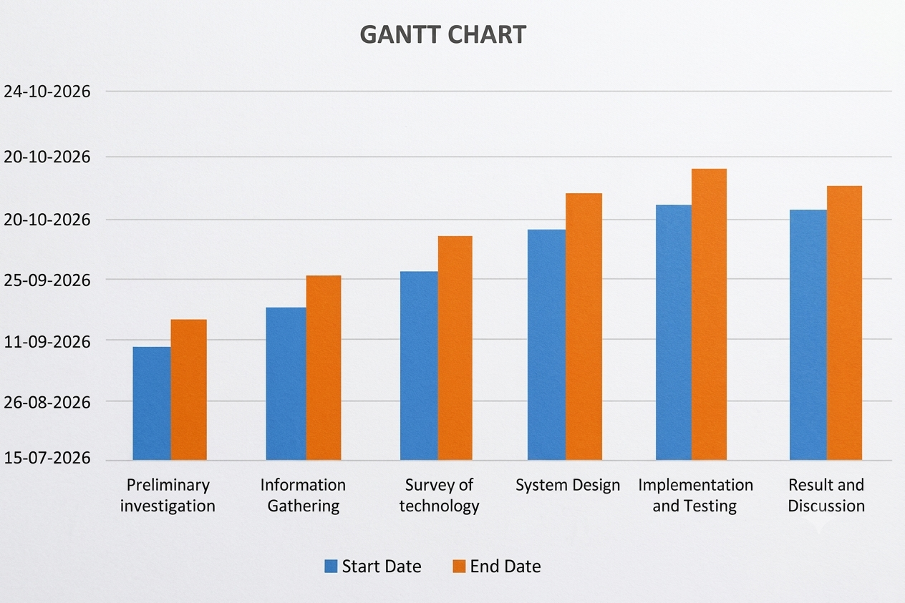

3.3.2 PERT Chart

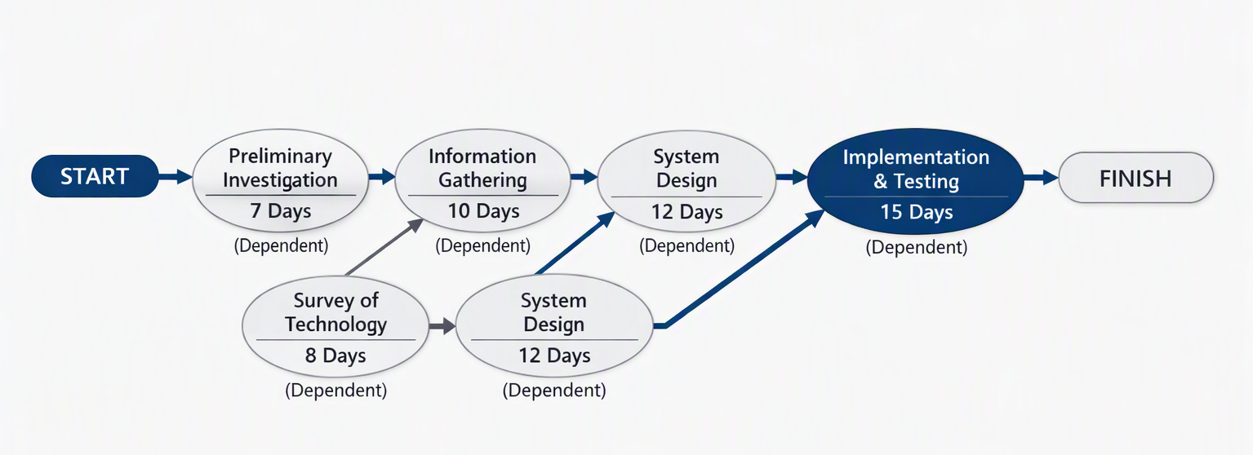

3.3.3 Activity Chart
Activity | Expected Start Date | Expected End Date | Actual Start Date | Actual End Date | Sign
Preliminary investigation | 15-07-2026 | 05-08-2026 | 15-07-2026 | 06-08-2026
Information Gathering | 06-08-2026 | 25-08-2026 | 07-08-2026 | 26-08-2026
Survey of technology | 26-08-2026 | 10-09-2026 | 27-08-2026 | 12-09-2026
System Design | 11-09-2026 | 30-09-2026 | 13-09-2026 | 02-10-2026
Implementation and Testing | 01-10-2026 | 20-10-2026 | 03-10-2026 | 22-10-2026
Result and Discussion | 21-10-2026 | 24-10-2026 | 23-10-2026 | 24-10-2026

3.4 Software and Hardware Requirements
Software and hardware requirements specify the resources required to develop, run, test, and maintain the BillNova application.
Software requirements describe the programming tools, frameworks, database systems, and supporting applications needed by the project. Hardware requirements describe the computer and other physical resources required for development and operation.
The specifications below provide a practical baseline for the project. Exact minimum requirements should be confirmed against the installed software versions and the final application.

3.4.1 Software Requirements
Software requirements include the operating system, programming language, framework, database software, development environment, and supporting libraries.

1. Operating System
A compatible operating system is required to run the development tools and application.
Microsoft Windows can be used for development with the selected technologies. Other operating systems may also be suitable if the required Python packages, database software, and application configuration are supported.

2. Python
Python is the programming language used for implementing the application's logic.
It supports functions such as processing user inputs, performing billing calculations, validating information, and communicating with the database through the relevant connector.
The Python version should be compatible with the Flask version and the installed dependencies.

3. Flask
Flask is the web framework used to manage application routes and handle requests.
It connects user actions with the appropriate application logic and supports the delivery of interface pages. It can also be used to process submitted forms and return the relevant results.

4. MySQL
MySQL is the relational database management system used to store structured business information.
Depending on the final database design, it may contain tables for products, customers, invoices, invoice items, and other supported information.
The database should be configured correctly so that the application can perform the required operations.

5. MySQL Connector
The MySQL connector allows the Python application to communicate with the MySQL database.
It supports database operations required by the application, including inserting, retrieving, updating, and deleting records.
The connector must be installed in the same Python environment used to run the application.

6. HTML
HTML is used to define the structure of the user interface.
It provides elements such as headings, forms, tables, navigation links, and other page components.

7. CSS
CSS is used to control the visual presentation of the application.
It defines layout, spacing, colours, typography, alignment, and other visual properties that contribute to the user experience.

8. JavaScript
JavaScript can be used to provide client-side interaction where required.
Examples include form interactions, dynamic interface behaviour, and other supported browser-side features.

9. Visual Studio Code
Visual Studio Code is the development environment used to edit and organize the project source code.
It supports code editing, terminal access, debugging extensions, and project-file management.

10. MySQL Workbench
MySQL Workbench is a database administration and development tool.
It can be used to connect to the database server, execute SQL statements, inspect tables, and manage database objects.

11. Web Browser
A compatible web browser is required to access the Flask application's interface during development and testing.
The application should be tested in the browser intended for the demonstration or use.

12. Python Virtual Environment
A Python virtual environment can be used to isolate project dependencies.
This helps reduce conflicts between package versions used by different Python projects.

13. Git and GitHub (Optional)
Git can be used for version control and tracking changes to the source code. GitHub may be used to host the repository if the project is published there.
These tools should only be included as completed project components if they are actually used.

Summary of Software Requirements
No. | Software | Purpose
1 | Microsoft Windows or compatible OS | Runs the development environment
2 | Python | Implements application logic
3 | Flask | Handles application routes and requests
4 | MySQL | Stores structured business records
5 | MySQL Connector | Connects Python with MySQL
6 | HTML | Defines page structure
7 | CSS | Styles the user interface
8 | JavaScript | Supports client-side interaction
9 | Visual Studio Code | Source-code editing and development
10 | MySQL Workbench | Database administration and SQL operations
11 | Compatible web browser | Accesses the application interface
12 | Python virtual environment | Isolates project dependencies
13 | Git/GitHub (optional) | Version control and repository hosting

3.4.2 Hardware Requirements
Hardware requirements describe the physical resources needed to develop and operate the application.
BillNova is a database-backed application whose hardware requirements depend on the size of the database, the development environment, and the expected workload. A typical student project can be developed on a standard personal computer.
The following specifications are suggested baseline requirements rather than measured minimums.

1. Processor
A modern processor capable of running the operating system, Python, a database service, and development tools is required.
A dual-core processor may be sufficient for basic development, while a more capable processor can improve responsiveness when several applications are open simultaneously.

2. RAM
RAM is required for the operating system, development environment, database service, and browser.
A minimum of 4 GB may be sufficient for some basic setups, but 8 GB or more is recommended for a more comfortable development experience when running Visual Studio Code, MySQL Workbench, a browser, and other tools together.

3. Storage
Storage is required for the source code, database files, installed software, project documentation, and backups.
An SSD is recommended because it can improve system responsiveness. The required storage capacity depends on the installed tools and the amount of project data.

4. Display
A standard monitor or laptop display is required to view the code editor, database tools, browser, and project documentation.
A higher-resolution display can make it easier to work with multiple windows and inspect application layouts.

5. Keyboard and Mouse
A keyboard is required for entering code, SQL statements, and project documentation. A mouse or compatible pointing device helps with navigation and interface testing.

6. Network Connection
An internet connection may be required to download software packages, consult documentation, access online resources, or publish the project repository.
A network connection is not necessarily required for every local application operation once the software and dependencies have been installed, but this depends on the implemented functions and deployment configuration.

7. Backup Storage
A suitable backup location is recommended for preserving project files, database backups, and documentation.
Backup storage may be provided by an external drive or an approved storage service, depending on the user's requirements and data-protection practices.

Summary of Hardware Requirements
No. | Hardware Component | Suggested Requirement | Purpose
1 | Processor | Modern dual-core or better | Runs the development tools
2 | RAM | 4 GB minimum baseline; 8 GB or more recommended | Supports simultaneous applications
3 | Storage | SSD recommended; sufficient free space | Stores software, code, database, and documents
4 | Display | Standard laptop or desktop display | Shows code and application interface
5 | Keyboard | Standard compatible keyboard | Code and data entry
6 | Mouse/pointing device | Standard compatible device | Navigation and testing
7 | Network | Internet connection when required | Software installation and online resources
8 | Backup storage | Suitable external or approved storage | Preserves project and database backups

Conclusion of Software and Hardware Requirements
The selected software technologies provide the necessary foundation for developing BillNova as a billing-management application. A standard personal computer with a compatible operating system, sufficient memory, storage, and the required development software should be suitable for a student-level implementation.
The actual hardware and software configuration should be documented according to the environment used to develop and test the final application.

3.5 Cost Benefit Analysis (COCOMO Model)
Cost-benefit analysis is used to compare the resources and costs required for developing and operating a software system with the benefits expected from its use.
The costs of a software project may include development time, hardware, software, testing, documentation, maintenance, and deployment. Benefits may include reduced repetitive work, improved record organization, more consistent calculations, and easier access to stored information.
For an academic project such as BillNova, the use of existing hardware and commonly available development technologies may reduce the additional monetary expenditure. However, the time and effort required for analysis, implementation, testing, and documentation remain important project resources.
The Constructive Cost Model, commonly known as COCOMO, is a software cost-estimation model developed by Barry Boehm. It estimates software development effort and schedule based on the estimated size of the software and the selected model parameters.
COCOMO provides an estimation framework. It does not measure the actual cost of a project unless realistic project-size and effort data are supplied.

3.5.1 Introduction to COCOMO
COCOMO stands for Constructive Cost Model. It is used to estimate the effort and development time required for a software project.
The basic COCOMO model estimates development effort using the software size expressed in thousands of lines of code, known as KLOC.
For the Basic COCOMO model, the effort equation is:
Effort (person-months)
Effort = a × (KLOC)^b
The development-time equation is:
Development Time (months)
Development Time = c × (Effort)^d
The coefficients depend on the selected project mode.
The traditional Basic COCOMO model uses three project modes:
Project Mode | General Description
Organic | Relatively small projects developed by an experienced team in a familiar environment
Semi-detached | Projects with intermediate complexity and mixed experience
Embedded | Projects with strong hardware, software, or operational constraints
The appropriate mode depends on the nature and constraints of the project. The mode should not be selected only because a project is small or large.

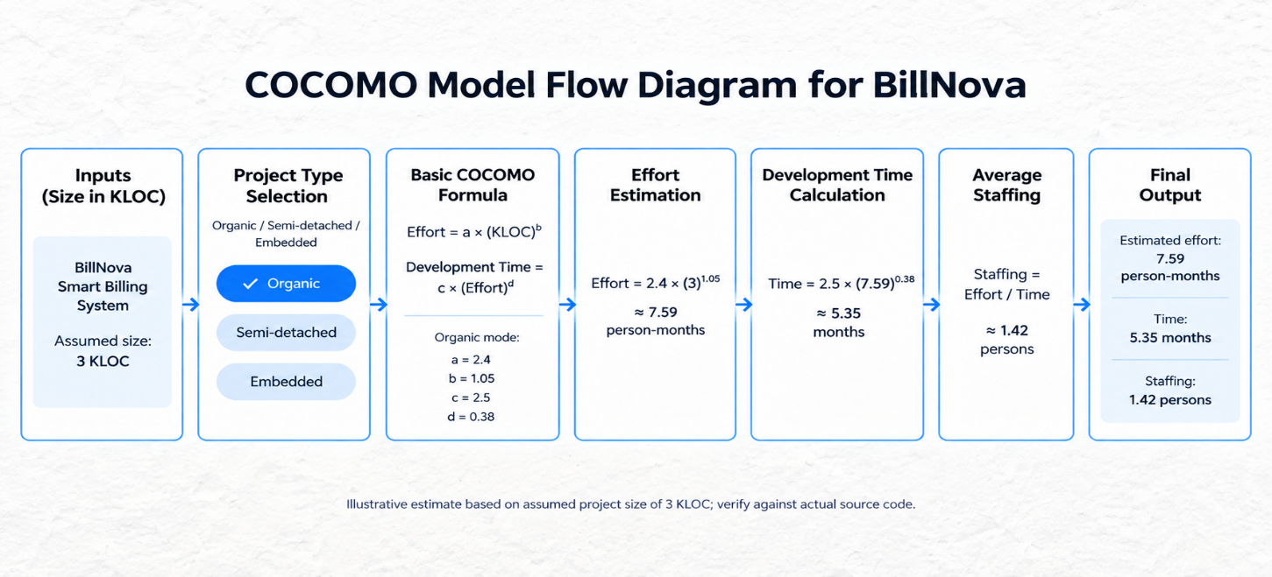

3.5.2 Basic COCOMO Equations
The standard Basic COCOMO equations and coefficients are summarized below.
Project Mode | Effort Equation | Development-Time Equation
Organic | Effort = 2.4 × (KLOC)^1.05 | Time = 2.5 × (Effort)^0.38
Semi-detached | Effort = 3.0 × (KLOC)^1.12 | Time = 2.5 × (Effort)^0.35
Embedded | Effort = 3.6 × (KLOC)^1.20 | Time = 2.5 × (Effort)^0.32
Here:
- KLOC represents thousands of lines of code.
- Effort is measured in person-months.
- Time is the estimated development duration in months.
- The coefficients depend on the selected project mode.
The estimated average staffing level can be calculated as:
Average Staffing = Effort / Development Time
This represents an approximate number of full-time-equivalent people over the estimated schedule. It is not necessarily the actual number of people working on a student project.

3.5.5 Cost Analysis of BillNova
The following table identifies the major cost categories associated with the project.
Cost Category | Description | Expected Treatment
Hardware | Computer, storage, and related equipment | Existing equipment may reduce additional expenditure
Software | Operating system, development tools, framework, and database | Depends on selected editions and licence terms
Development | Time required for analysis, design, coding, and integration | Important project resource
Testing | Time spent preparing and executing tests and correcting defects | Required for quality assurance
Documentation | Time spent preparing diagrams, report sections, and user instructions | Required for academic submission
Maintenance | Corrections and future updates | May be required after development
Deployment | Installation, hosting, or other operational resources | Depends on the chosen deployment method
Backup | Storage and procedures for preserving data | Should be considered for data protection
The actual cost depends on the resources already available, the amount of work required, and whether any paid services or equipment must be purchased.

3.5.6 Benefit Analysis of BillNova
The expected benefits of BillNova are primarily related to improved organization and reduced repetitive effort.
1. Reduced Billing Effort
The application aims to simplify invoice preparation by providing a structured workflow and reusing stored information where supported.
2. Improved Calculation Consistency
Application-based calculations can reduce repeated manual arithmetic. Correctness must still be verified through testing.
3. Organized Business Records
Database-backed storage can help organize product, customer, and invoice information.
4. Easier Retrieval
Supported listing and detail functions can make it more convenient to access previously saved records.

3.5.7 Cost-Benefit Comparison
Aspect | Manual or Disconnected Approach | Expected BillNova Benefit
Invoice preparation | May require repeated entry and manual calculations | A structured workflow can reduce repetitive steps
Calculation | Depends on manual arithmetic or separate formulas | Implemented calculations can improve consistency
Record storage | May be distributed across paper records and files | Database-backed organization of supported records
Record retrieval | May require manual searching | Available search and listing functions
Product information | May be maintained separately | Centralized product records where implemented
Customer information | May be maintained in separate records | Centralized customer records where implemented
Development cost | May not require software-development effort | Requires time for development, testing, and maintenance
Operating cost | Depends on the existing process | Depends on hardware, configuration, and deployment
Future extension | May require changes to existing tools or procedures | Additional software features can be developed

3.5.8 Limitations of COCOMO Estimation
Although COCOMO provides a structured method for estimating software effort, its accuracy depends on the quality of the input data and the suitability of the selected model.
The main limitations include:
- Dependence on software size: Incorrect KLOC estimates can produce misleading effort estimates.
- Dependence on project mode: Selecting an unsuitable mode affects the result.
- Model assumptions: Basic COCOMO uses general equations that may not reflect every project-specific condition.
- Uncertain requirements: Changes in scope may increase the effort required.
- Developer experience: Actual effort depends on the skills and experience of the developer or team.
- Testing and rework: Unexpected defects can increase the development time.
- Monetary cost variation: The cost per person-month differs across organizations and locations.
- Academic project constraints: A student's actual working hours and cash expenditure may differ from the full-time staffing assumptions used by the model.
For these reasons, the calculation should be treated as an estimate rather than a guarantee of actual development effort or cost.

3.5.9 Conclusion of Cost-Benefit Analysis
The cost-benefit analysis indicates that BillNova can be developed using commonly available programming and database technologies. Using an existing computer and available development tools may reduce the additional monetary expenditure associated with the project.
The expected benefits include a more organized billing workflow, reduced repetitive data entry, more consistent supported calculations, and improved access to stored business information.
The illustrative Basic COCOMO calculation demonstrates how estimated source-code size can be used to estimate development effort and schedule. The final project-specific estimate must be recalculated using the actual code size and appropriate project assumptions.
Overall, the proposed system may provide useful benefits for its intended billing-management purpose. Its actual effectiveness should be evaluated through implementation review, testing, and, where possible, comparison of the time and effort required to complete representative billing tasks.

CHAPTER 4: SYSTEM DESIGN

4.1 Use case diagram
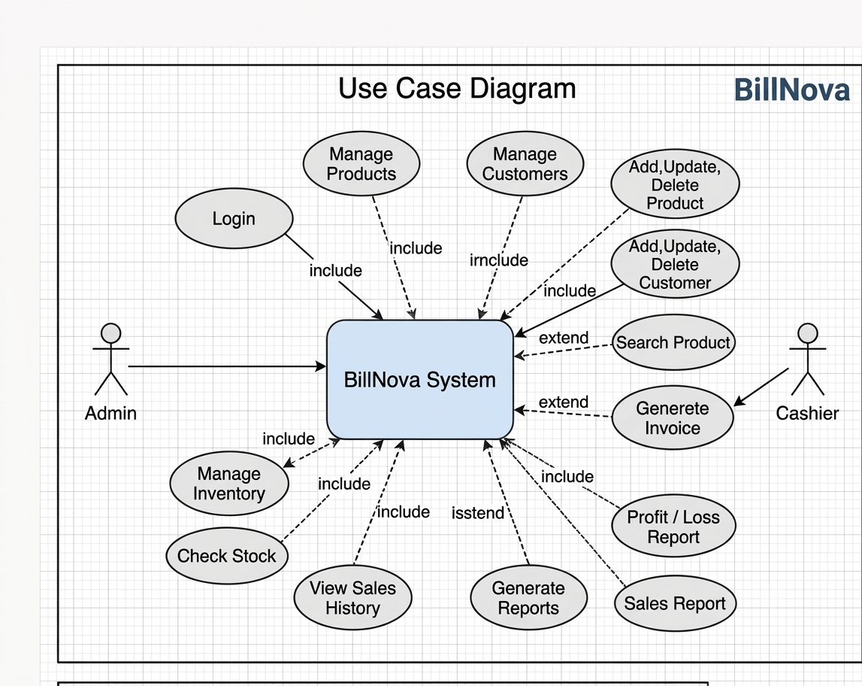4.2 ACTIVITY MODEL
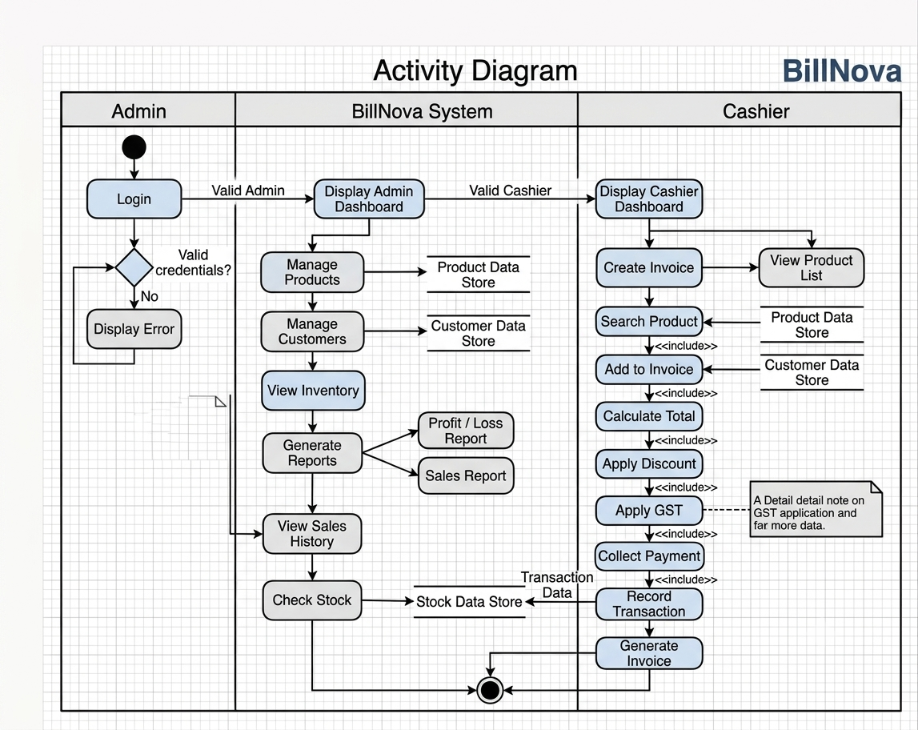
4.3 CLASS DIAGRAM
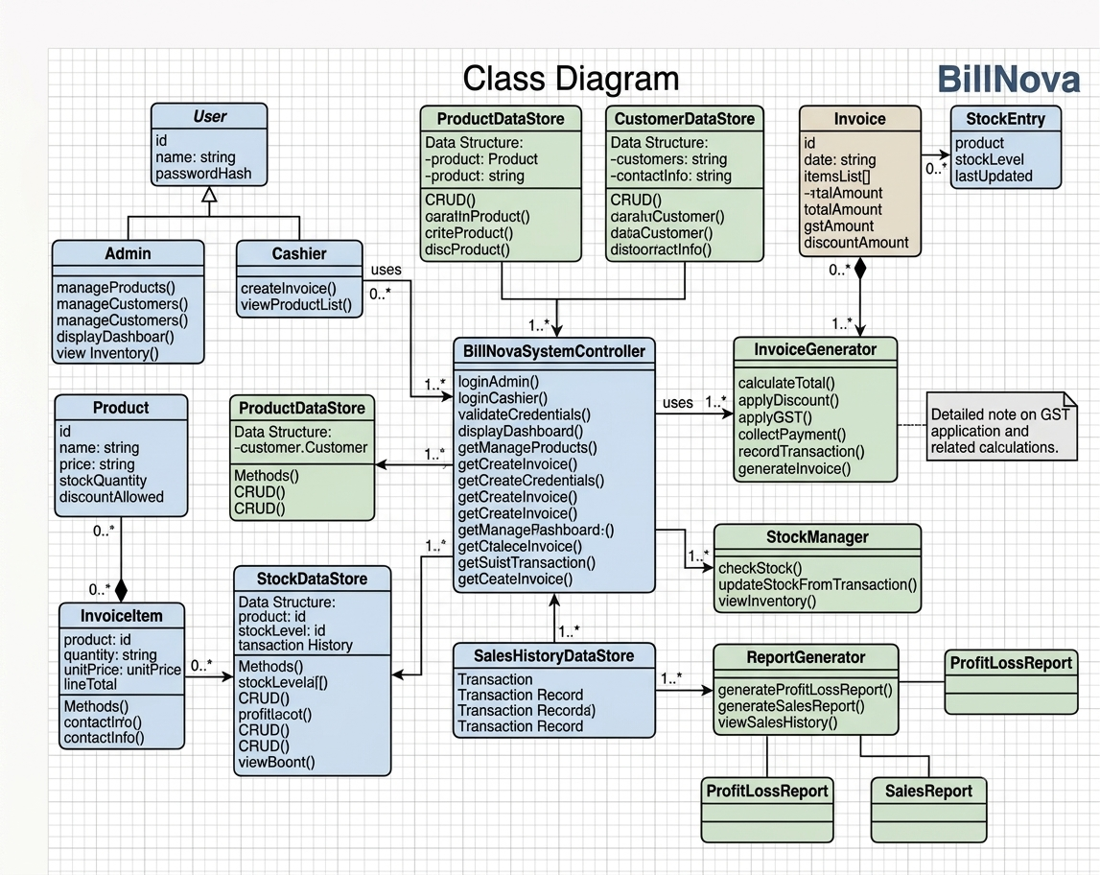

4.4 ER diagram

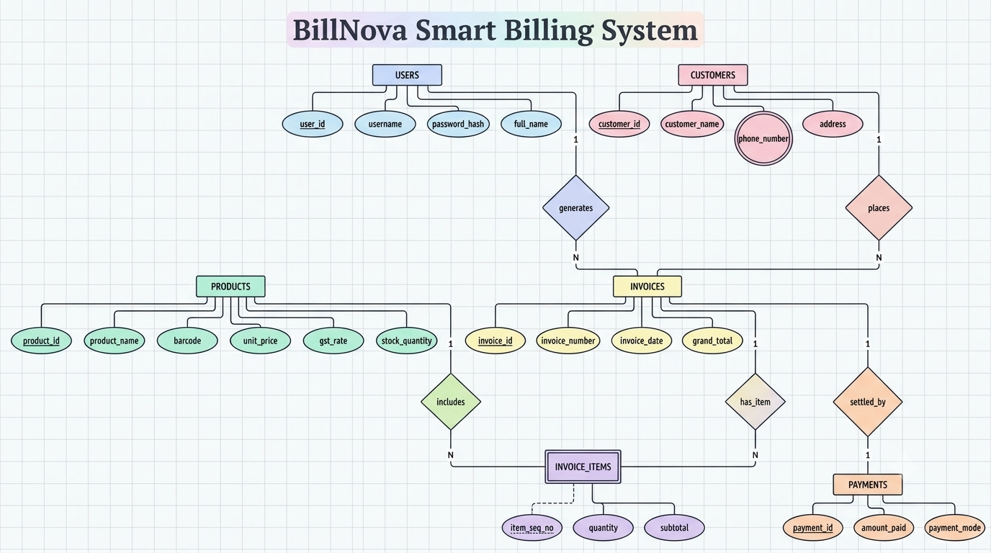
4.5 Component Diagram
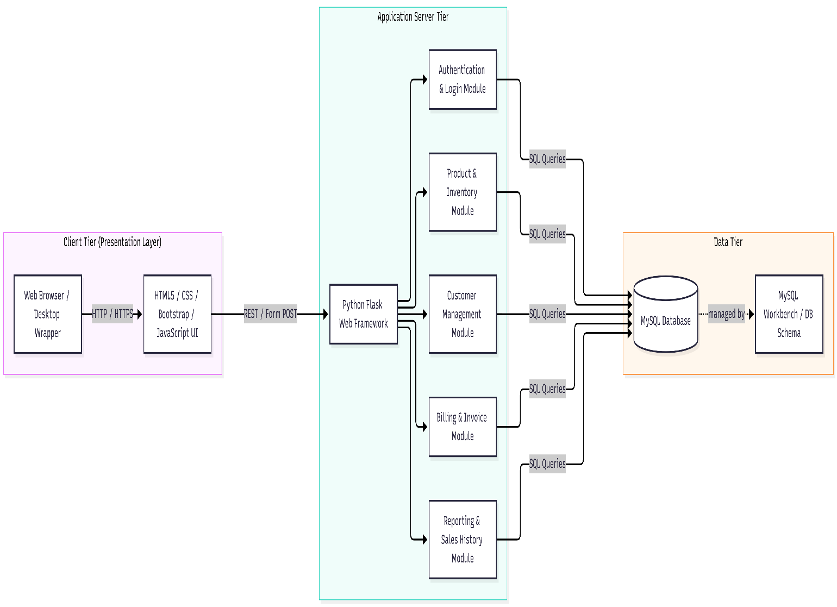

4.6 DATA FLOW DIAGRAM
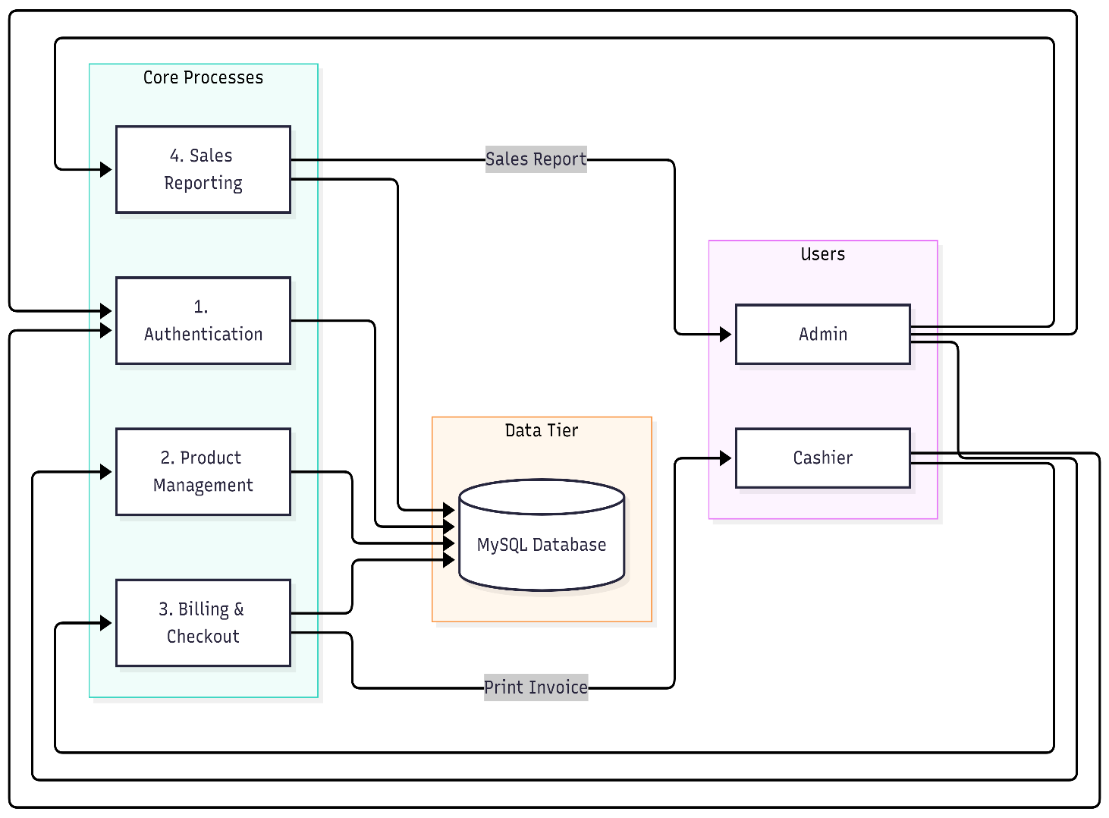
WEBSITE WORK FLOW DIAGRAM
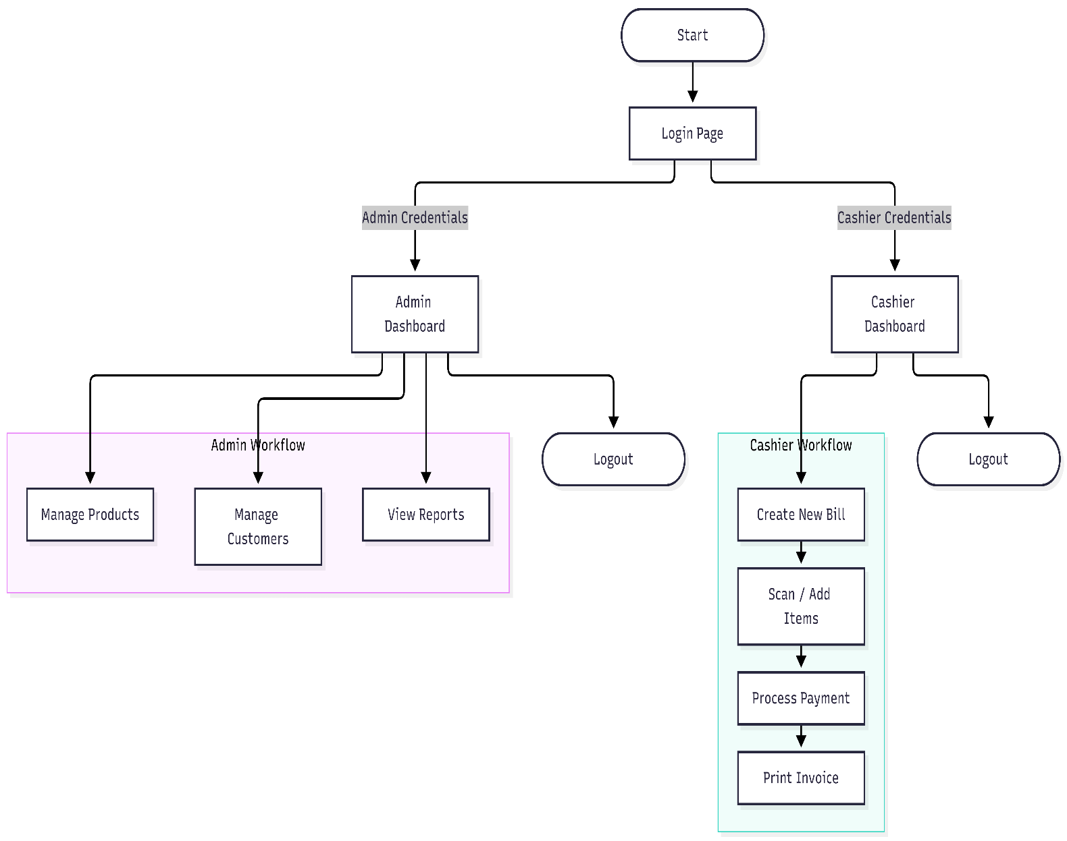
LIST OF TABLES
I. Admin_User Table
Column Name | Data Type | Constraints | Description
user_id | INT | PRIMARY KEY, AUTO_INCREMENT | Unique identifier for system operators.
username | VARCHAR(50) | NOT NULL, UNIQUE | Login username.
password_hash | VARCHAR(255) | NOT NULL | Encrypted password string.
role | ENUM('Admin', 'Cashier') | NOT NULL | Access privilege level.
created_at | TIMESTAMP | DEFAULT CURRENT_TIMESTAMP | Account creation timestamp.
II. Customer Table
Column Name | Data Type | Constraints | Description
customer_id | INT | PRIMARY KEY, AUTO_INCREMENT | Unique customer identifier.
name | VARCHAR(100) | NOT NULL | Full name of the customer.
phone | VARCHAR(15) | NOT NULL | Contact phone number.
email | VARCHAR(100) | NULL | Optional email address.
address | TEXT | NULL | Customer residential/billing address.
III. Product Table
Column Name | Data Type | Constraints | Description
product_id | INT | PRIMARY KEY, AUTO_INCREMENT | Unique item identifier in inventory.
name | VARCHAR(100) | NOT NULL | Product name.
category | VARCHAR(50) | NOT NULL | Item classification category.
price | DECIMAL(10, 2) | NOT NULL | Unit selling price.
stock_quantity | INT | NOT NULL, DEFAULT 0 | Available stock count.
gst_rate | DECIMAL(5, 2) | NOT NULL, DEFAULT 0.00 | Applicable tax rate percentage.
IV. Invoice Table
Column Name | Data Type | Constraints | Description
invoice_id | INT | PRIMARY KEY, AUTO_INCREMENT | Unique bill receipt number.
customer_id | INT | FOREIGN KEY $→$Customer(customer_id) | Reference to the purchasing customer.
user_id | INT | FOREIGN KEY $→$Admin_User(user_id) | Reference to the processing cashier/admin.
invoice_date | DATETIME | DEFAULT CURRENT_TIMESTAMP | Date and time bill was issued.
subtotal | DECIMAL(10, 2) | NOT NULL | Total cost before taxes.
gst_amount | DECIMAL(10, 2) | NOT NULL | Total GST applied.
total_amount | DECIMAL(10, 2) | NOT NULL | Final payable amount.
V. Invoice_Items Table
Column Name | Data Type | Constraints | Description
item_id | INT | PRIMARY KEY, AUTO_INCREMENT | Unique line-item entry ID.
invoice_id | INT | FOREIGN KEY $→$Invoice(invoice_id) | Parent invoice reference.
product_id | INT | FOREIGN KEY $→$Product(product_id) | Purchased product reference.
quantity | INT | NOT NULL | Number of units purchased.
unit_price | DECIMAL(10, 2) | NOT NULL | Price per unit at time of sale.
line_total | DECIMAL(10, 2) | NOT NULL | Calculated subtotal ($quantity×unit_price$).
VI. Sales_History_Report Table
Column Name | Data Type | Constraints | Description
report_id | INT | PRIMARY KEY, AUTO_INCREMENT | Unique ledger log ID.
invoice_id | INT | FOREIGN KEY $→$Invoice(invoice_id) | Corresponding bill invoice.
sale_date | DATETIME | NOT NULL | Date transaction was logged.

CHAPTER 5 : IMPLEMENTATION AND TESTING

5.1 Tools and Technology
BillNova is a Smart Billing Management System developed to simplify billing operations and organize business information. The system uses programming languages, web technologies, database software, and development tools to implement its functionality. These technologies work together to provide application logic, user interface design, database connectivity, and data management.
The following tools and technologies are used in the development of BillNova.

5.1.1 Python
Python is the primary programming language used to develop the backend functionality of BillNova. It is used to implement application logic, process user requests, perform validations, and manage billing-related operations. Its simple syntax and extensive libraries make it suitable for application development.

5.1.2 Flask
Flask is a lightweight Python web framework used to manage application routes and handle requests. It connects the user interface with backend logic and helps process operations such as displaying records, submitting forms, and interacting with the database.

5.1.3 MySQL
MySQL is a relational database management system used to store and manage structured business information. Depending on the implemented database schema, this information may include product details, customer records, invoice information, and other billing-related data. The database supports storing, retrieving, and updating records when required.

5.1.4 HTML
HTML (HyperText Markup Language) is used to create the structure of the application's web pages. It defines elements such as headings, forms, input fields, buttons, tables, and navigation sections.

5.1.5 CSS
CSS (Cascading Style Sheets) is used to design and style the user interface. It controls layout, spacing, colours, fonts, borders, and other visual elements. CSS helps maintain a consistent appearance across the application's pages.

5.1.6 JavaScript
JavaScript can be used to provide client-side interactivity, form validation, and dynamic behaviour in the user interface. It should be included in the final technology list if it is present in the implemented version of BillNova.

5.1.7 MySQL Connector
MySQL Connector for Python is used to establish communication between the Python application and the MySQL database. It enables the application to execute SQL queries and perform database operations such as inserting, retrieving, updating, and deleting records.

5.1.8 Visual Studio Code
Visual Studio Code is used as the code editor and development environment. It supports writing and organizing source code, managing project files, running the application, and identifying coding errors during development.

5.1.9 MySQL Workbench
MySQL Workbench is used to connect to and manage the MySQL database. It provides an interface for executing SQL queries, creating and modifying tables, inspecting database structures, and checking stored records.

5.2 Screenshots
Screenshots provide visual evidence of the implemented features of BillNova. They help explain the application's interface and demonstrate how users interact with its different modules.
The screenshots included in the final report should be captured from the actual running application. Each screenshot should have a figure number, a descriptive caption, and a short explanation.

5.2.1 Login Page
The login page provides an entry point to the application. It allows an authorized user to access the system using the credentials supported by the implemented login functionality.
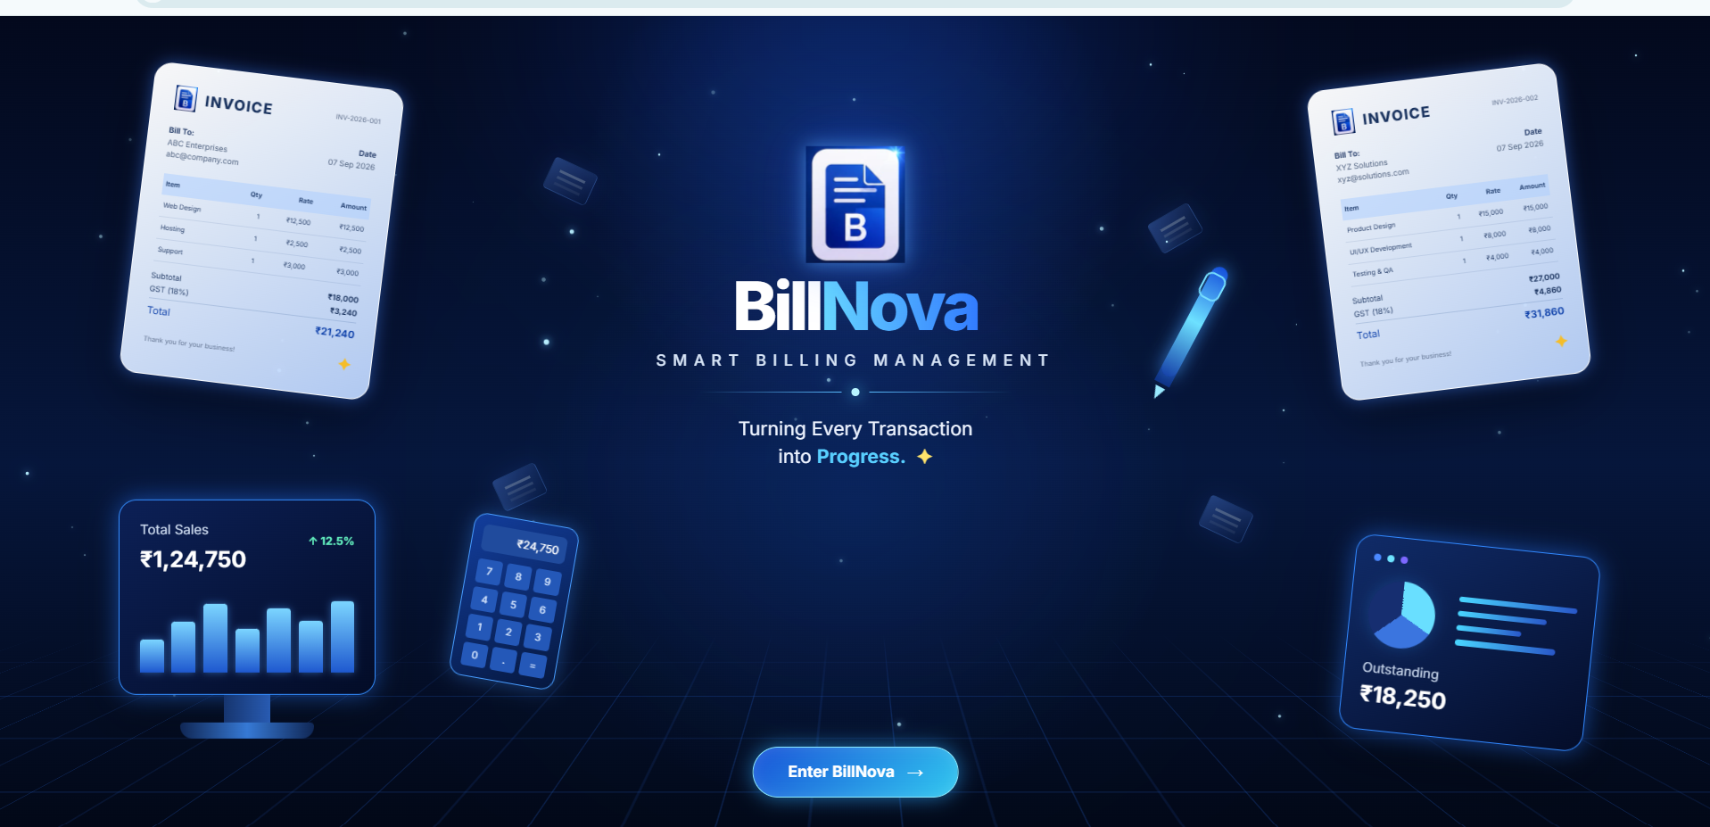
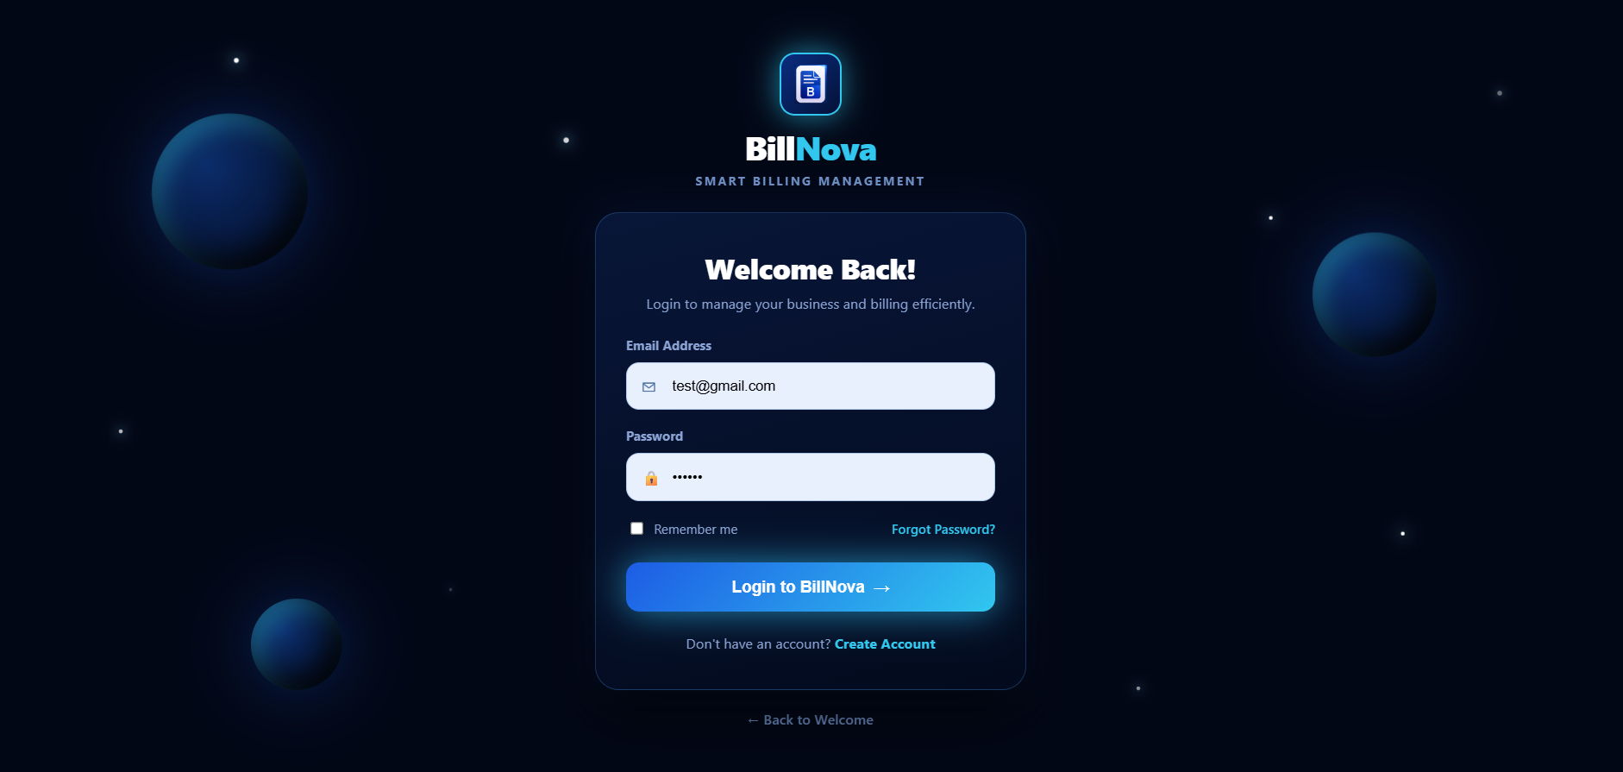

5.2.2 Dashboard
The dashboard presents an overview of the application's main functions. Depending on the implemented features, it may provide access to product management, customer management, invoice operations, and business summaries.

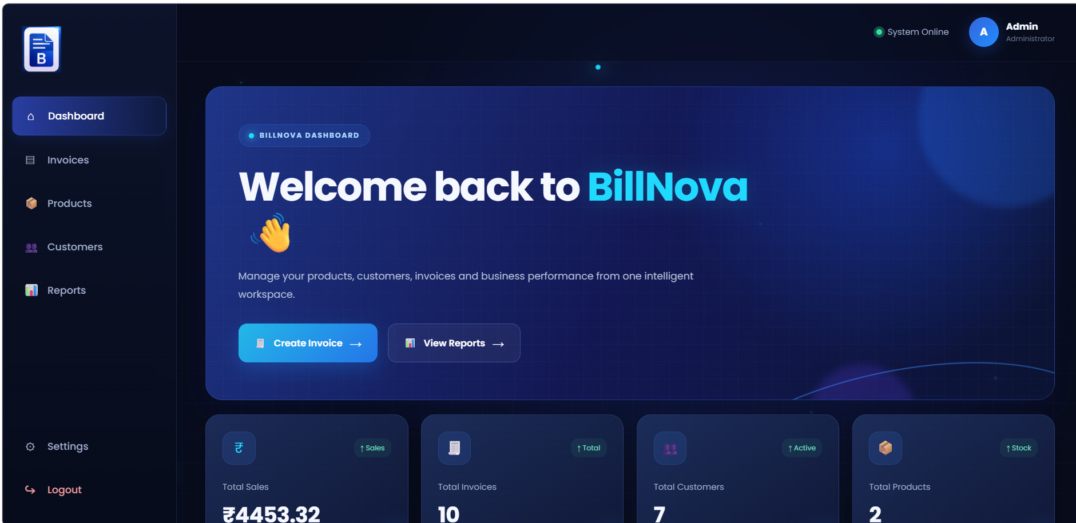

5.2.3 Product Management
The product management section is used to maintain product information. Its implemented operations may include adding new products, viewing existing products, editing details, and deleting records.
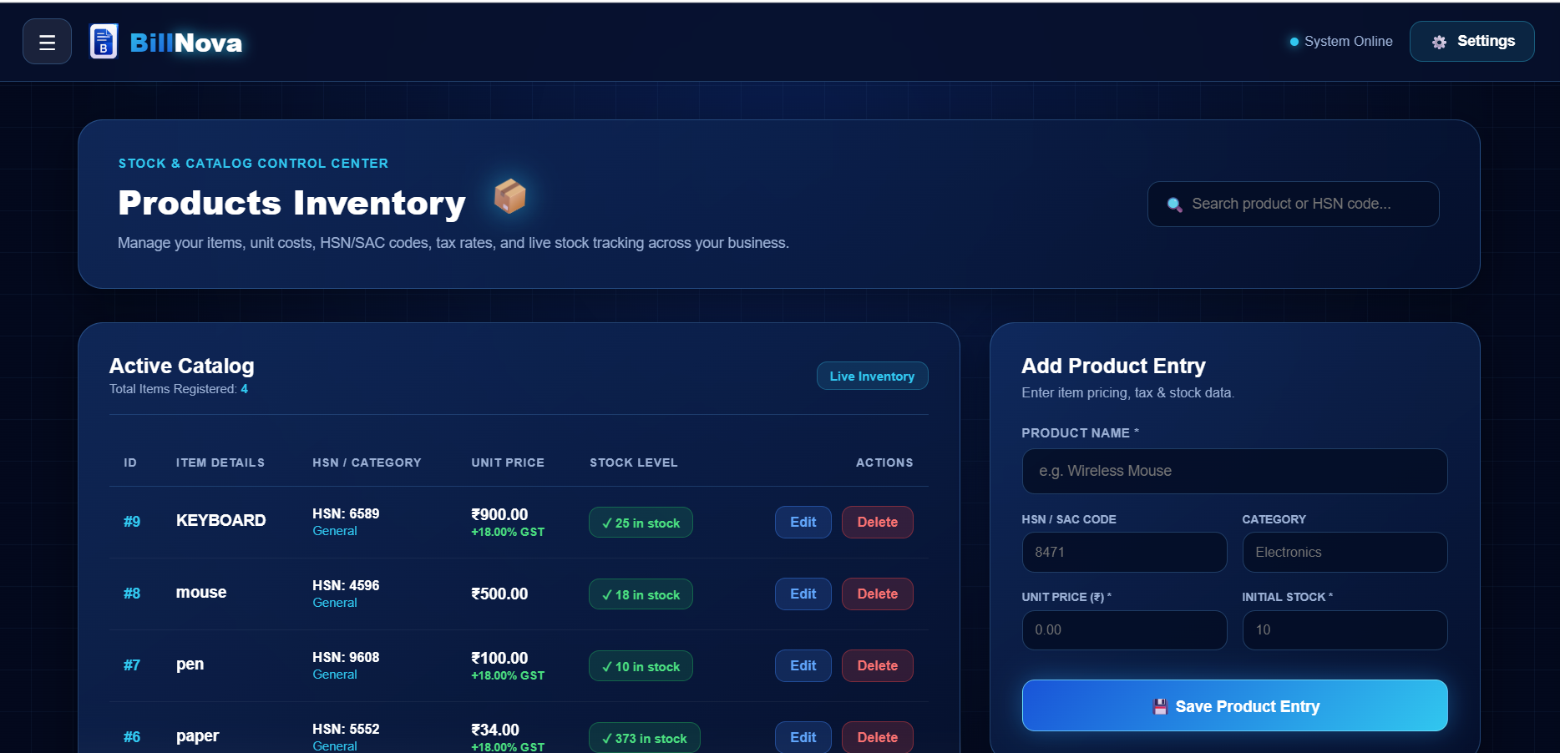

5.2.4 Customer Management
The customer management section maintains customer information required for billing. The fields and available operations should match the actual version of the application.

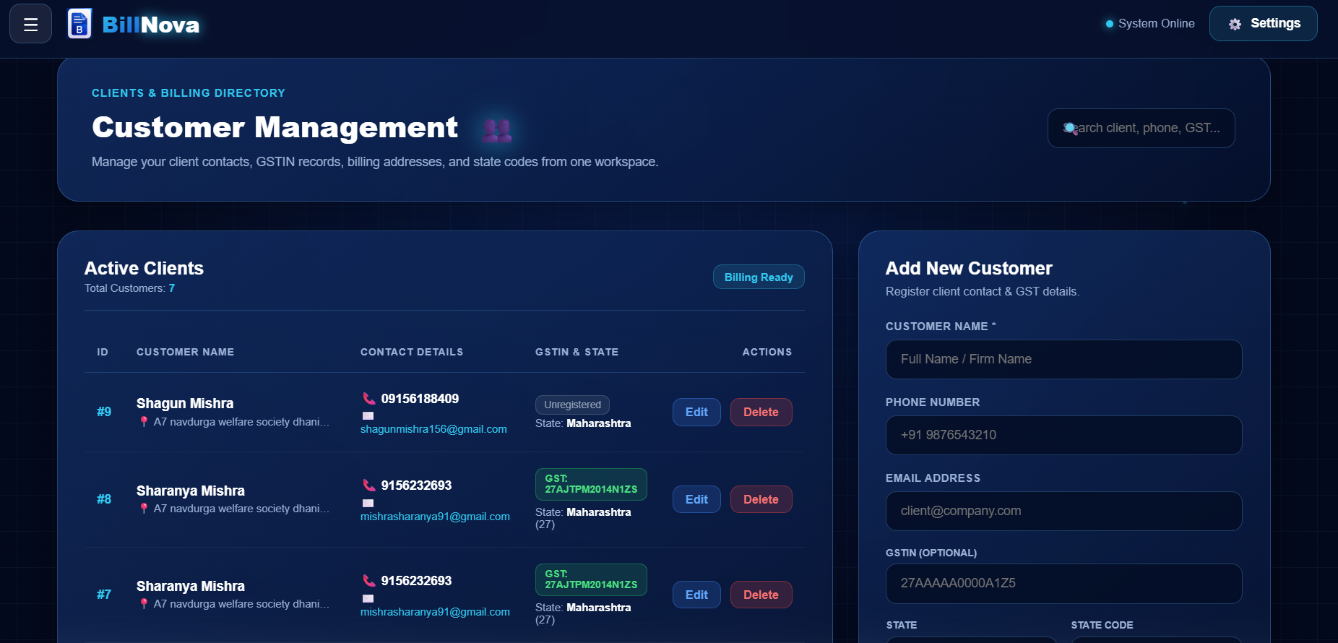

5.3 Coding
The coding phase involves converting the system requirements and design into executable program instructions. BillNova uses Python for backend processing, Flask for request handling, and MySQL for data storage. HTML and CSS are used to build the user interface.
The source code is organized into application logic, interface templates, styling resources, and database-related operations according to the project's implementation.

5.3.1 Backend Coding
The backend handles application operations and processes requests received from the user interface. Python functions and Flask routes are used to perform the operations supported by the system.
from flask import Flask, render_template, request, redirect, url_for, flash, session
import mysql.connector
from decimal import Decimal, ROUND_HALF_UP
from datetime import datetime
import os
import uuid
from werkzeug.utils import secure_filename
from werkzeug.security import generate_password_hash, check_password_hash

# =========================================================
# FLASK APP
# =========================================================

app = Flask(__name__)

app.secret_key = "billnova_secret_key"

# =========================================================
# DATABASE CONFIGURATION
# =========================================================

def get_db_connection():
return mysql.connector.connect(
host="127.0.0.1",
user="root",
password="root123",
database="billnova"
)

# =========================================================
# UPLOAD CONFIGURATION
# =========================================================

UPLOAD_FOLDER = os.path.join(
app.root_path,
"static",
"uploads",
"logos"
)

ALLOWED_EXTENSIONS = {
"png",
"jpg",
"jpeg",
"webp"
}

os.makedirs(UPLOAD_FOLDER, exist_ok=True)

def allowed_file(filename):
return (
"." in filename
and filename.rsplit(".", 1)[1].lower()
in ALLOWED_EXTENSIONS
)

# =========================================================
# HELPER FUNCTIONS
# =========================================================

def get_decimal(value, default=Decimal("0.00")):
try:
if value is None or value == "":
return default

return Decimal(str(value))

except Exception:
return default

def money(value):
value = get_decimal(value)

return value.quantize(
Decimal("0.01"),
rounding=ROUND_HALF_UP
)

# =========================================================
# NUMBER TO WORDS
# =========================================================

def number_to_words(number):

number = int(Decimal(str(number)))

if number == 0:
return "Zero Rupees Only"

ones = [
"",
"One",
"Two",
"Three",
"Four",
"Five",
"Six",
"Seven",
"Eight",
"Nine",
"Ten",
"Eleven",
"Twelve",
"Thirteen",
"Fourteen",
"Fifteen",
"Sixteen",
"Seventeen",
"Eighteen",
"Nineteen"
]

tens = [
"",
"",
"Twenty",
"Thirty",
"Forty",
"Fifty",
"Sixty",
"Seventy",
"Eighty",
"Ninety"
]

5.3.2 Database Coding
SQL queries are used to interact with the MySQL database. Database operations may include inserting new records, retrieving stored information, modifying existing data, and deleting records.
Input validation and appropriate database error handling are important to help maintain data consistency and reduce the risk of invalid operations.

5.3.3 Frontend Coding
The frontend provides the interface through which users access the application's features. HTML defines the page structure, while CSS controls the visual appearance. JavaScript is used where required for client-side interaction.
<!DOCTYPE html>
<html lang="en">

<head>
<meta charset="UTF-8">

<meta name="viewport" content="width=device-width, initial-scale=1.0">

<title>Welcome | BillNova</title>

<link rel="stylesheet"
href="{{ url_for('static', filename='css/welcome.css') }}">

<link rel="preconnect"
href="https://fonts.googleapis.com">

<link rel="preconnect"
href="https://fonts.gstatic.com"
crossorigin>

<link href="https://fonts.googleapis.com/css2?family=Inter:wght@400;500;600;700;800&display=swap"
rel="stylesheet">

</head>

<body>

<main class="welcome-page">

<!-- BACKGROUND GLOWS -->
<div class="bg-glow glow-one"></div>
<div class="bg-glow glow-two"></div>

<!-- SPARKLING PARTICLES -->
<div id="particles"></div>

<!-- FLOATING PAPERS -->
<div class="floating-paper paper-one"></div>
<div class="floating-paper paper-two"></div>
<div class="floating-paper paper-three"></div>
<div class="floating-paper paper-four"></div>

<!-- LEFT INVOICE -->
<div class="invoice-card invoice-left">

<div class="invoice-header">

<div class="invoice-brand">

<img src="{{ url_for('static', filename='images/billnova_logo.png') }}"
alt="BillNova">

<span>INVOICE</span>

</div>

<div class="invoice-number">
INV-2026-001
</div>

</div>

<div class="invoice-details">

<div>

<strong>Bill To:</strong>

<p>ABC Enterprises</p>
<p>abc@company.com</p>

</div>

<div class="invoice-date">

<strong>Date</strong>

<p>07 Sep 2026</p>

</div>

</div>

<table>

<thead>

<tr>
<th>Item</th>
<th>Qty</th>
<th>Rate</th>
<th>Amount</th>
</tr>

</thead>

<tbody>

<tr>
<td>Web Design</td>
<td>1</td>
<td>₹12,500</td>
<td>₹12,500</td>
</tr>

<tr>
<td>Hosting</td>
<td>1</td>
<td>₹2,500</td>
<td>₹2,500</td>
</tr>

<tr>
<td>Support</td>
<td>1</td>
<td>₹3,000</td>
<td>₹3,000</td>
</tr>

</tbody>

</table>

<div class="invoice-summary">

<div>
<span>Subtotal</span>
<strong>₹18,000</strong>
</div>

<div>
<span>GST (18%)</span>
<strong>₹3,240</strong>
</div>

<div class="invoice-grand-total">
<span>Total</span>
<strong>₹21,240</strong>
</div>

<tr>
<td>UI/UX Development</td>
<td>1</td>
<td>₹8,000</td>
<td>₹8,000</td>
</tr>

<tr>
<td>Testing & QA</td>
<td>1</td>
<td>₹4,000</td>
<td>₹4,000</td>
</tr>

</tbody>

</table>

<div class="invoice-summary">

</script>

</body>

</html>

5.4 GitHub Repository
GitHub is a platform used to store, manage, and share source code through version control. A GitHub repository can help maintain the development history of BillNova and make the project files easier to manage.
If BillNova has been uploaded to GitHub, this section should include the actual repository details.
Repository Name: PROJECT
Repository URL: https://github.com/Sharanya150706/project
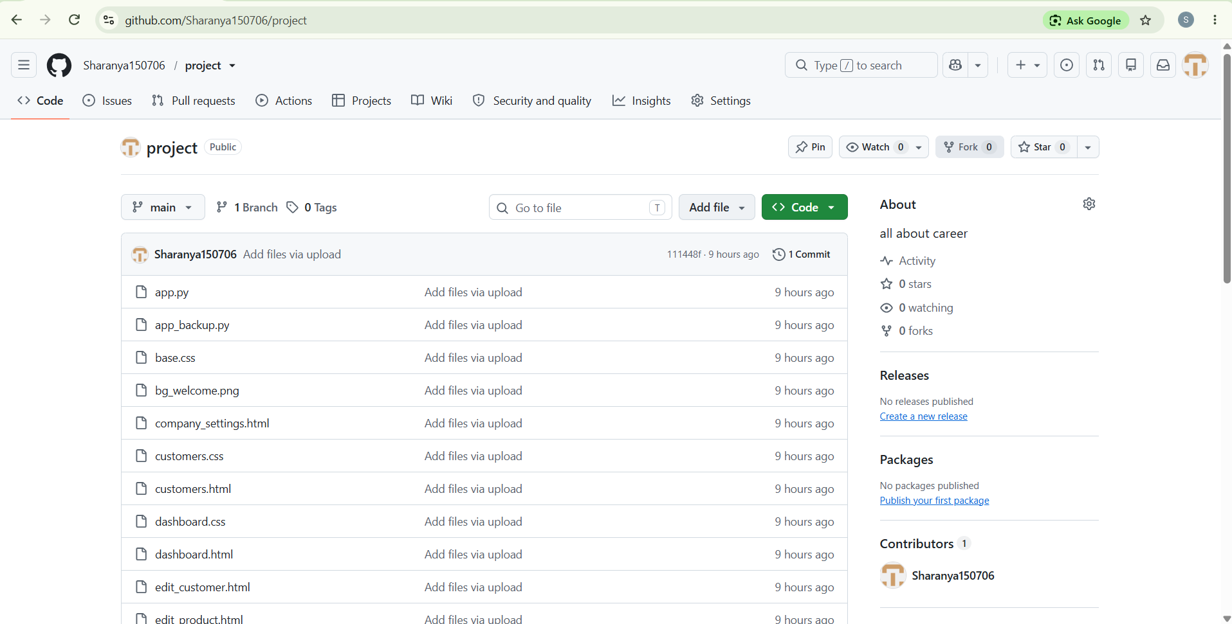

5.5 Testing Approaches
Software testing is performed to determine whether an application behaves according to its requirements and to identify defects before the system is used. Testing helps assess the correctness, reliability, and usability of BillNova.
The following approaches can be used to test the application.

5.5.1 Unit Testing
Unit testing checks individual functions or components separately. In BillNova, individual functions responsible for input validation, database operations, calculations, and record processing can be tested independently.
For example, an invoice calculation function can be tested using known product prices, quantities, and applicable tax rates. The calculated result can then be compared with the expected result.
Unit testing helps identify errors within individual components before they are combined with other parts of the system.

5.5.2 Integration Testing
Integration testing checks whether different modules work correctly when connected. BillNova contains components that may need to communicate with one another, such as the user interface, Flask backend, MySQL database, and invoice module.
For example, when a user submits product information, the application should validate the input, save the record in the database, and display the updated information correctly.
Integration testing helps identify issues involving database connectivity, data transfer, and communication between modules.

5.5.3 Beta Testing
Beta testing involves allowing a small group of intended users to evaluate the application in realistic usage conditions before wider release. Users can provide feedback about the interface, workflow, and ease of completing common billing tasks.
For BillNova, beta testing may involve asking users to try supported tasks such as entering product details, maintaining customer records, or generating invoices. Feedback can be recorded and used to identify improvements.
This section should describe beta testing as completed only if actual users have tested the application. Otherwise, it should be presented as a planned testing approach.

5.6 Types of Testing
Different types of testing can be applied to evaluate the functionality and quality of BillNova.

5.6.1 Functional Testing
Functional testing checks whether each feature performs its intended operation. Examples include verifying login behaviour, saving product records, retrieving customer information, and generating invoices.

5.6.2 Validation Testing
Validation testing checks whether the application accepts valid information and handles invalid or incomplete input appropriately. For example, required fields should be checked before records are saved.

5.6.3 Database Testing
Database testing verifies whether records are stored, retrieved, updated, and deleted correctly. It also checks whether the application displays the information returned by the database accurately.

5.6.4 Interface Testing
Interface testing checks the appearance and behaviour of the user interface. It includes checking navigation links, buttons, input fields, tables, readability, and consistency across pages.

5.6.5 Regression Testing
Regression testing is performed after code changes to confirm that previously working features have not been affected. For example, changes to invoice calculations should be followed by checks of invoice creation and display.

5.6.6 Error Handling Testing
Error handling testing checks how the application responds to unexpected conditions, such as invalid input, database connection failures, or unavailable records. The application should provide suitable feedback without unnecessarily exposing technical details.

5.7 Test Cases
Test cases describe the inputs, actions, and expected results used to verify a system's behaviour. The following table provides a proposed test-case set for BillNova. The actual results and status must be filled in after executing each test on the implemented application.
Test Case ID | Test Scenario | Expected Result
TC-01 | Open the application | The application should load without an unexpected error.
TC-02 | Enter valid login credentials | Access should be granted according to the implemented authentication rules.
TC-03 | Enter invalid login credentials | Access should be denied and suitable feedback displayed.
TC-04 | Add a product with valid details | The product should be saved and displayed correctly.
TC-05 | Submit a product form with missing required data | The application should reject the invalid submission or display validation feedback.
TC-06 | Edit an existing product | The updated product details should be saved and displayed.
TC-07 | Add a customer with valid details | The customer record should be saved successfully.
TC-08 | Edit an existing customer | The updated customer information should be reflected in the system.
TC-09 | Create an invoice using valid details | The invoice should be generated with correct information and calculations.
TC-10 | Check invoice tax calculations | Tax and total amounts should match the applicable rules and expected calculations.
TC-11 | Retrieve saved records | The application should display the correct stored information.
TC-12 | Test database connectivity | Database operations should succeed when the database is available and provide suitable error handling when it is unavailable.
Actual Result: To be recorded after executing each test case.
Status: To be marked as Pass or Fail based on the observed result.
A test case should be marked as Pass only when the observed result matches the expected result. If the results differ, the test should be marked as Fail, the defect should be recorded, and the relevant component should be corrected and retested.

5.8 Test Reports
A test report summarizes the testing activities performed on the application. It records the test cases executed, observed results, defects identified, and the status of the system after testing.
The report helps determine whether the implemented functions meet their requirements and identifies areas that need further improvement.

5.8.1 Test Execution Summary
The following table can be completed after testing the actual BillNova application.
Particular | Details
Project Name | BillNova — Smart Billing Management System
Testing Type | Functional, validation, database, interface, and regression testing, as performed
Total Test Cases | To be recorded
Test Cases Passed | To be recorded
Test Cases Failed | To be recorded
Defects Identified | To be recorded
Retested Defects | To be recorded
Final Testing Status | To be determined from actual results

5.8.2 Defect Reporting
A defect is an observed difference between the expected behaviour and the actual behaviour of the application. Each defect should be recorded with sufficient information to reproduce and investigate it.
A defect record may contain:
- Defect identification number.
- Module or feature affected.
- Steps to reproduce the problem.
- Expected result.
- Actual result.
- Severity or priority.
- Current status, such as Open, Fixed, or Retested.

5.8.3 Final Testing Evaluation
The final testing evaluation should be prepared after the planned tests have been executed. It should summarize the functions that were verified, any unresolved defects, and the improvements required before the application is considered ready for its intended use.
Testing provides greater confidence in the application's behaviour, but it does not guarantee that the software is completely free from defects. Further testing and maintenance may be necessary when new features are added or existing modules are modified.

CHAPTER 6: MAINTENANCE

6.1 Conclusion (Summary of Project)
BillNova — Smart Billing Management System is a software application designed to simplify and organize billing-related activities for businesses. The project aims to reduce the difficulties associated with manual billing and the maintenance of business records by providing a centralized system for managing relevant information.
Traditional manual billing methods may involve repeated data entry, handwritten calculations, difficulty retrieving older records, and a greater possibility of human error. BillNova aims to address these problems by organizing billing operations through a software-based approach.
The project uses Python for application logic, Flask for backend request handling, and MySQL for storing structured information. HTML and CSS support the user interface, while MySQL Connector enables communication between the application and its database.
The system is intended to support important billing activities, including product management, customer management, and invoice-related operations, according to the functionality implemented in the application. Appropriate validation and testing are important to ensure that the stored information and calculations are processed correctly.
The development of BillNova also provides practical experience in software engineering concepts such as requirement analysis, database design, application development, user-interface design, and software testing. The project demonstrates how programming languages and database technologies can be combined to develop a solution for a practical business problem.
In conclusion, BillNova provides a foundation for a structured and user-friendly billing management application. Its effectiveness depends on the correct implementation and testing of its features. With further development and maintenance, the system can be extended to support additional business requirements and improve the overall billing workflow.

6.2 Limitations
Although BillNova aims to simplify billing activities, certain limitations may exist in the current version of the system. These limitations depend on the features implemented, the available infrastructure, and the testing performed.

6.2.1 Dependence on Database Availability
The application depends on its MySQL database for storing and retrieving business information. If the database service is unavailable or the connection fails, database-dependent functions may not operate correctly.

6.2.2 Limited Reporting Capabilities
The availability of business reports depends on the reporting functions implemented in the current version. Advanced analytics, detailed sales comparisons, and forecasting may require additional development.

6.2.3 Limited Multi-User Support
If the current version is configured for a single administrator or a single local environment, it may not provide complete multi-user functionality. User roles, access permissions, and simultaneous access controls may need to be added for larger organizations.

6.2.4 Security Enhancements
The application requires appropriate authentication, authorization, input validation, secure configuration, and database access controls. Additional security testing may be necessary before using the system for sensitive business information in a production environment.

6.2.5 Backup and Recovery
Business records are important and should be protected against accidental deletion, hardware failure, and data corruption. If automated backup and recovery features are not implemented, database backups must be managed separately until these features are added.

6.3 Future Enhancement
BillNova can be enhanced in the future to provide additional functionality, improve usability, strengthen security, and support the needs of a wider range of businesses. The following enhancements are proposed for future versions of the system.

6.3.1 Advanced Business Reports
The system can be extended to generate detailed sales reports, monthly summaries, product-wise sales reports, and customer-related reports. These reports could help business owners understand sales activity and make informed decisions.

6.3.2 Inventory Management Improvements
Future versions could include automatic stock updates after invoice generation, configurable low-stock alerts, reorder notifications, and stock movement history. These features could help reduce stock-management errors and improve inventory control.

6.3.3 Advanced Analytics and Sales Forecasting
Analytical features could be introduced to identify sales trends and estimate future demand using historical data. Any forecast should be presented as an estimate and should be evaluated against actual business results.

6.3.4 Multi-User Access and Role Management
The application could support multiple users with different permissions, such as administrator, billing operator, and inventory manager. Role-based access control would help restrict sensitive operations to authorized users.

CHAPTER 7: REFERENCES

The following references provide information related to the programming languages, frameworks, database management systems, and software development concepts used in the development of BillNova — Smart Billing Management System.
- Python Software Foundation. Python Documentation. Available at: https://docs.python.org/3/
- Pallets Projects. Flask Documentation. Available at: https://flask.palletsprojects.com/
- Oracle. MySQL Reference Manual. Available at: https://dev.mysql.com/doc/
- Oracle. MySQL Connector/Python Developer Guide. Available at: https://dev.mysql.com/doc/connector-python/en/
- World Wide Web Consortium (W3C). HTML Standards and Specifications. Available at: https://www.w3.org/standards/webdesign/htmlcss
- Mozilla Developer Network (MDN). HTML: HyperText Markup Language. Available at: https://developer.mozilla.org/en-US/docs/Web/HTML
- Mozilla Developer Network (MDN). CSS: Cascading Style Sheets. Available at: https://developer.mozilla.org/en-US/docs/Web/CSS
- Mozilla Developer Network (MDN). JavaScript Guide. Available at: https://developer.mozilla.org/en-US/docs/Web/JavaScript/Guide
- Microsoft. Visual Studio Code Documentation. Available at: https://code.visualstudio.com/docs
- Oracle. MySQL Workbench Manual. Available at: https://dev.mysql.com/doc/workbench/en/
- Pressman, R. S., and Maxim, B. R. Software Engineering: A Practitioner's Approach. McGraw-Hill Education.
- Sommerville, I. Software Engineering. Pearson.
- Boehm, B. W. Software Engineering Economics. Prentice Hall.
- Project source code, database schema, and development notes prepared during the development of BillNova.

Reference Note
The online documentation listed above can be consulted for technical information about the tools and technologies used in the project. The software engineering books provide background on software development, testing, maintenance, and cost estimation.
Only references that were actually consulted should be retained in the final report. If a particular technology or book was not used, remove it from the list. Add the access date for online sources if required by the college's prescribed referencing format.

CHAPTER 8: GLOSSARY

A glossary is a collection of important technical terms used in a project along with their meanings. It helps readers understand the terminology related to the development, implementation, database, and testing of BillNova — Smart Billing Management System.
Sr. No. | Term | Definition
1 | BillNova | The name of the Smart Billing Management System developed to organize billing-related activities.
2 | Billing System | A software application used to prepare, manage, and maintain bills or invoices.
3 | Invoice | A document containing details of products or services, prices, applicable taxes, and the total amount payable.
4 | Customer | A person or business that purchases products or services.
5 | Product | An item maintained in the system for billing and related business operations.
6 | Inventory | The collection of products or goods maintained by a business.
7 | Database | An organized collection of information that can be stored, retrieved, and updated.
8 | DBMS | Database Management System; software used to create, manage, and access databases.
9 | MySQL | A relational database management system used to store and manage structured data.
10 | Python | A programming language used to implement application logic and backend operations.
11 | Flask | A lightweight Python web framework used to handle application routes and requests.
12 | HTML | HyperText Markup Language, used to structure web pages.
13 | CSS | Cascading Style Sheets, used to control the appearance and layout of web pages.
14 | JavaScript | A programming language used to add interactive behaviour to web pages, where implemented.
15 | Frontend | The part of an application that users interact with directly.
16 | Backend | The part of an application responsible for processing requests, applying business logic, and communicating with the database.
17 | SQL | Structured Query Language, used to retrieve and manipulate data in relational databases.
18 | CRUD | Create, Read, Update, and Delete; the four basic operations used to manage records.
19 | Authentication | The process of verifying a user's identity.
20 | Authorization | The process of determining what an authenticated user is permitted to access or perform.
21 | Validation | Checking whether entered data satisfies specified rules and requirements.
22 | Primary Key | A database field or combination of fields that uniquely identifies a record in a table.
23 | Foreign Key | A database field used to establish a relationship between tables.
24 | Database Connectivity | The mechanism through which an application communicates with a database.
25 | MySQL Connector | A software library that allows Python applications to connect to a MySQL database.
26 | GST | Goods and Services Tax, a tax applied to eligible supplies according to applicable rules.
27 | CGST | Central Goods and Services Tax, generally applicable to eligible intra-state supplies under Indian GST rules.
28 | SGST | State Goods and Services Tax, generally applicable to eligible intra-state supplies under Indian GST rules.
29 | Tax Calculation | The process of calculating applicable tax amounts based on the relevant taxable value and tax rate.
30 | Dashboard | A screen that presents an overview of important information and provides access to application functions.
31 | User Interface (UI) | The visual elements through which a user interacts with an application.
32 | Software Development Life Cycle (SDLC) | A structured process involving activities such as planning, analysis, design, development, testing, deployment, and maintenance.
33 | Incremental Model | A software development model in which a system is developed and delivered in smaller functional increments.
34 | Agile Methodology | An iterative approach to software development that emphasizes feedback, collaboration, and adaptation to changing requirements.
35 | Unit Testing | Testing an individual function or component separately.
36 | Integration Testing | Testing whether connected modules work correctly together.
37 | Functional Testing | Testing whether the application performs the functions specified in its requirements.
38 | Regression Testing | Testing previously working features after a change to check that they still function correctly.
39 | Test Case | A documented set of conditions, inputs, actions, and expected results used to verify a feature.
40 | Defect | A flaw that causes the actual behaviour of the software to differ from the expected behaviour.
41 | COCOMO | Constructive Cost Model, a model used to estimate software development effort and schedule based on project size and other factors.

CHAPTER 9: APPENDIX

The appendix contains supplementary information that supports the main content of the project report. It provides additional technical details, sample structures, supporting documents, and evidence related to the development of BillNova — Smart Billing Management System.
The purpose of this chapter is to provide readers with supporting information that may be useful for understanding the system's implementation and evaluation.

9.1 Appendix A: Sample Database Structure
BillNova uses MySQL for database management. The database stores structured information required by the application. The exact tables and fields should correspond to the database schema used in the final project.
The following are examples of the types of information that may be maintained, depending on the implemented schema:
Information Category | Purpose
User information | Supports user accounts and authentication, if implemented.
Product information | Stores product details required for billing.
Customer information | Maintains customer records used during billing.
Invoice information | Stores invoice-level information, such as invoice number and date.
Invoice item information | Stores product-wise details belonging to an invoice, if the system supports multiple items per invoice.
Note: Replace these example categories with the actual table names and fields from the BillNova database.

9.2 Appendix B: Sample Input and Output
This section provides examples of the information entered into the application and the expected output. The examples below are illustrative and should not be presented as actual test results unless verified using the application.

Sample Product Input
Field | Illustrative Value
Product Name | Notebook
Price | ₹50.00
Quantity | 20

Sample Invoice Output
An invoice may contain the following information, depending on the implemented invoice format:
- Business name and contact information.
- Invoice number and invoice date.
- Customer details.
- Product description, quantity, and price.
- Applicable tax details.
- Subtotal and final payable amount.
The final amount must be calculated according to the applicable tax rules and the actual invoice calculation implemented in BillNova.

9.3 Appendix C: Sample Test Case Record
The following format can be used to record the results of testing the application.
Particular | Description
Test Case ID | TC-01
Module | Product Management
Test Objective | Verify that a valid product can be added.
Test Input | Valid product details entered through the application.
Expected Result | The product should be saved and displayed correctly.
Actual Result | To be recorded after executing the test.
Status | To be marked Pass or Fail after verification.
This record helps maintain a clear history of the testing activities performed during project development.

9.4 Appendix D: Project Screenshots
Screenshots of the actual running application can be included to provide visual evidence of its implementation.
The following screenshots may be attached, if the corresponding modules are available:
- Application login page.
- Main dashboard.
- Product management page.
- Customer management page.
- Invoice creation page.
- Generated invoice.
- Database tables or relevant database records.
- Additional implemented modules.
Each screenshot should have a figure number and a short caption. Screenshots should be clear, readable, and captured from the actual project.

9.5 Appendix E: Source Code and Repository Details
This section may include information about the project's source code and repository.
Project Name: BillNova — Smart Billing Management System
Programming Language: Python
Backend Framework: Flask
Database: MySQL
Repository URL: https://github.com/Sharanya150706/project
The complete source code may be maintained separately in the project folder or repository. Only relevant code excerpts should be added to the printed report when necessary. Passwords, private credentials, and other sensitive configuration values must not be included.

9.6 Appendix F: Supporting Documents
The following documents may be attached according to the college's project-report requirements:
- Approved project proposal.
- Plagiarism report, self-attested if required.
- Additional diagrams that support the system design.
- Actual test execution records.
- Other relevant project evidence requested by the college.
The approved proposal and plagiarism report should be included in the preliminary section if the college template specifically requires them there. They need not be duplicated in the appendix unless instructed.

Appendix Summary
This appendix provides supporting material for the BillNova project report. It is intended to supplement the main chapters with relevant technical information, screenshots, test records, and project documentation. All final attachments should correspond to the actual implementation and verified project evidence.

